Year 10 |  | Non Right Triangle Trigonometry | Calculator Allowed
Skills and Knowledge Assessed:  - Apply Pythagoras’ theorem and trigonometry to solving three - dimensional problems in right- angled triangles (ACMMG276)  - Use the unit circle to define trigonometric functions, and graph them with and without the use of digital technologies (ACMMG274)  - Solve simple trigonometric equations (ACMMG275)  - Establish the sine, cosine and area rules for any triangle and solve related problems (ACMMG273) |  |  | Name_________________
Section 1 Short Answer Section
Write all working and answers in the spaces provided on this test paper.

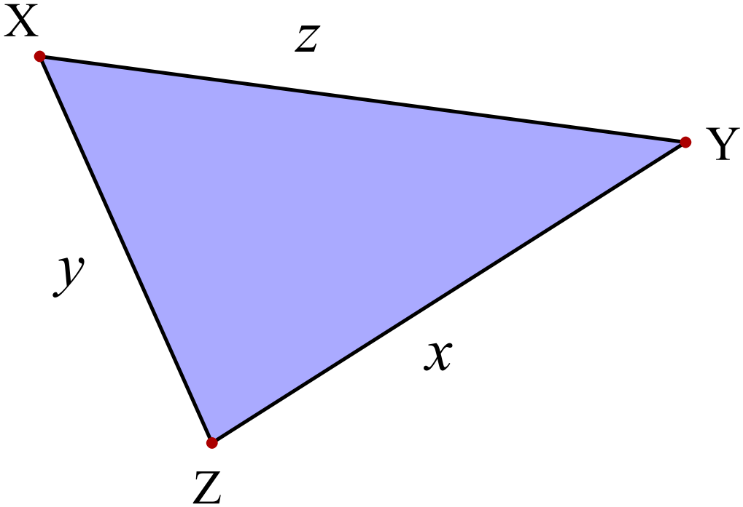Use the sine rule to write an equation which could be used to find the value of y in 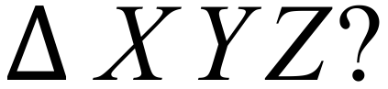

………………………………………………

……………………………………………....

Write a statement of the cosine rule that could be used to find the value of f in 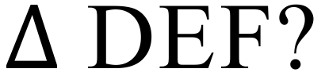

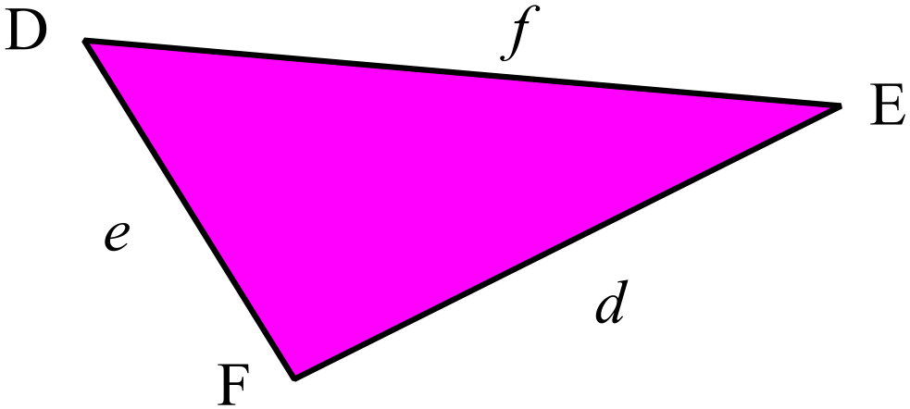………………………………………………

……………………………………………....

………………………………………………

……………………………………………….
Use the cosine rule to find the length of PQ correct to 1 decimal place.
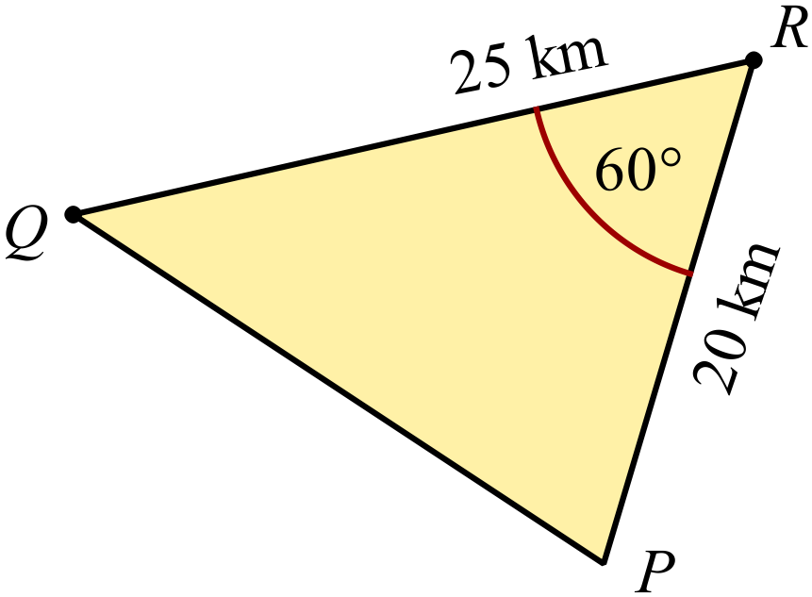

………………………………………………

……………………………………………....

………………………………………………

………………………………………………
Use the sine rule to find the size of 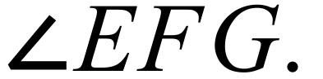
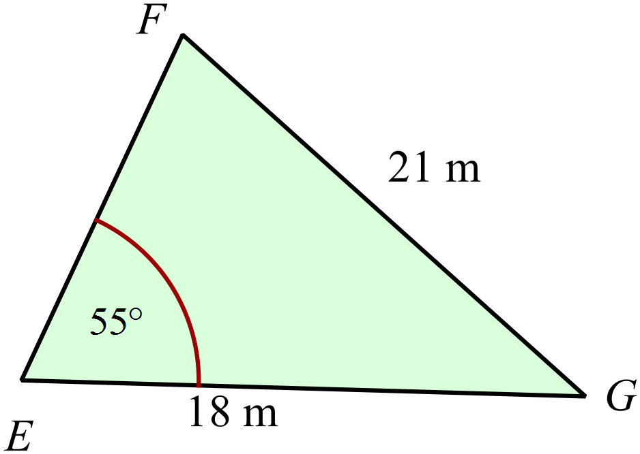

………………………………………………

……………………………………………....

………………………………………………

……………………………………………….
If 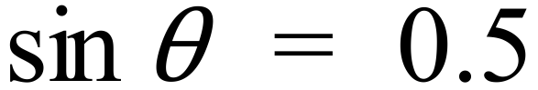 and 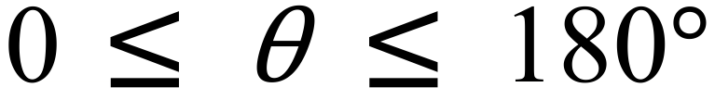 find all the possible values of 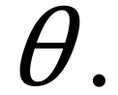

……………………………………………………………………………………………....

……………………………………………………………………………………………….
Find the value of a, correct to the nearest mm.

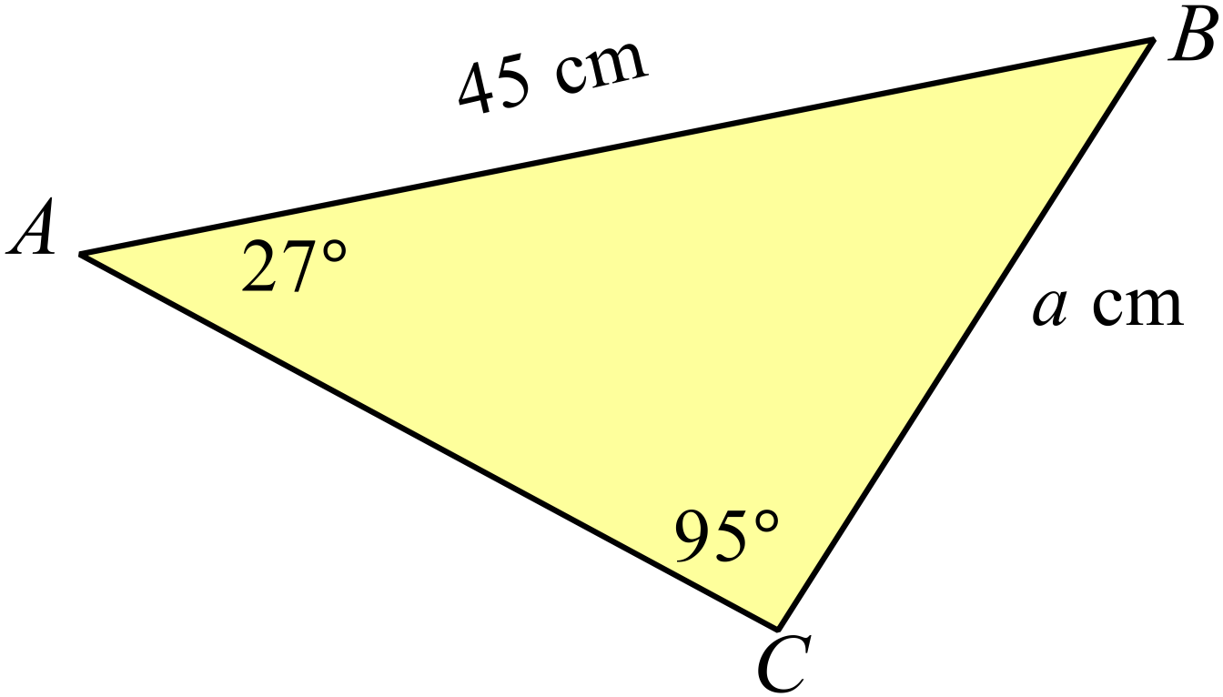

………………………………………………

……………………………………………....

………………………………………………

……………………………………………….
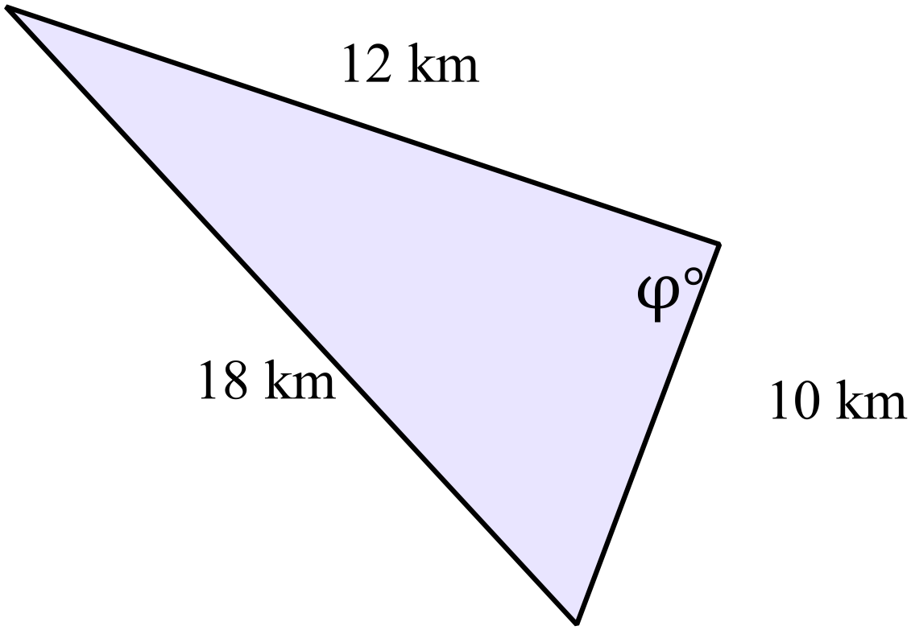What is the value of 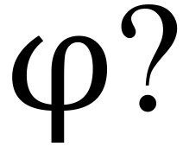
Answer to the nearest degree.

………………………………………………

……………………………………………....

………………………………………………

……………………………………………….
Find the area of 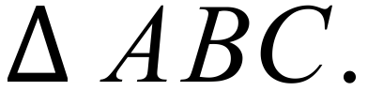
Answer to the nearest cm².
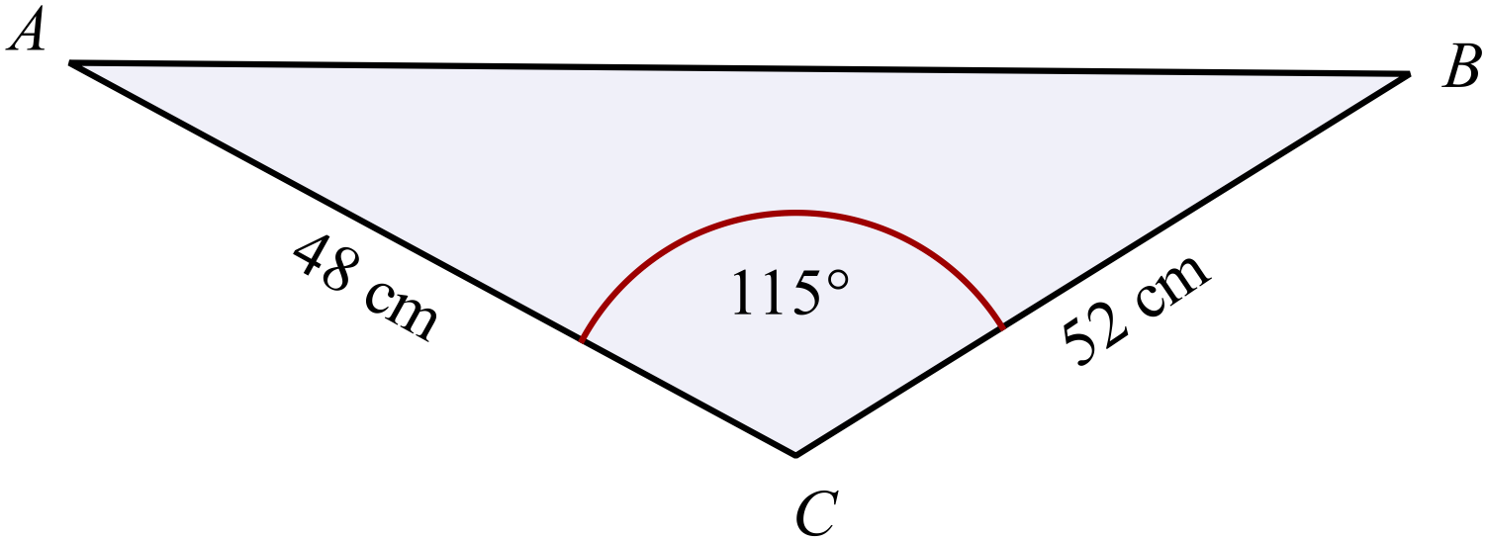
………………………………………………

……………………………………………....

………………………………………………

……………………………………………….
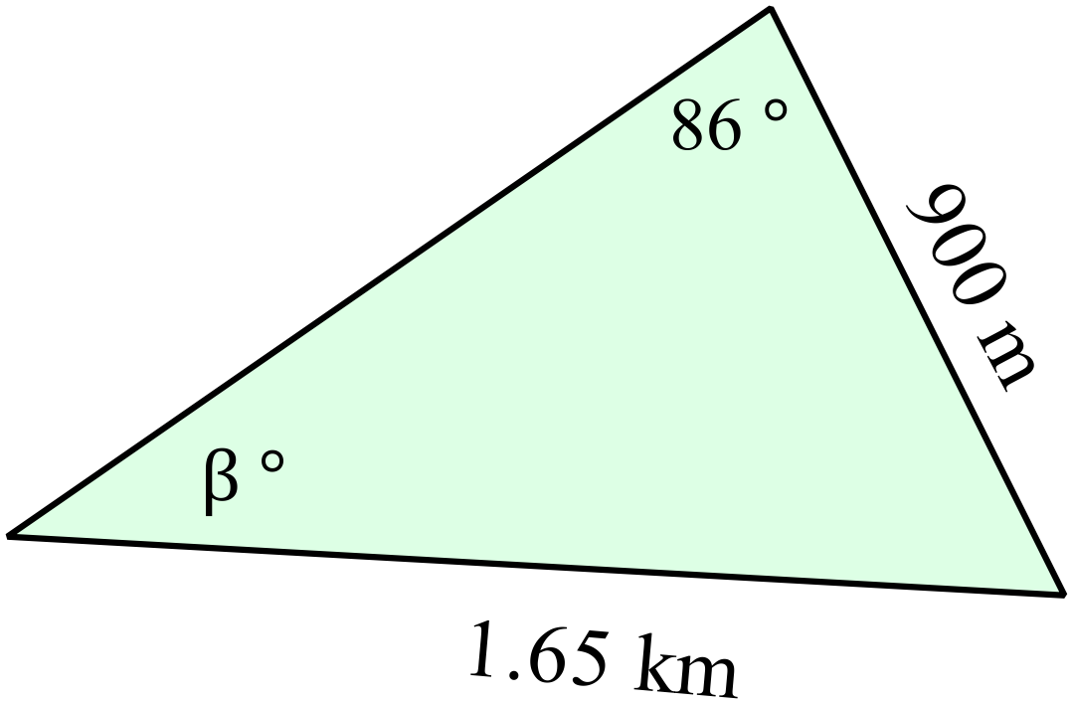Find the value of 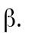
Answer to the nearest degree.

………………………………………………

……………………………………………....

………………………………………………

……………………………………………….
Find all possible values of 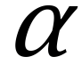 between 0º and 360º such that 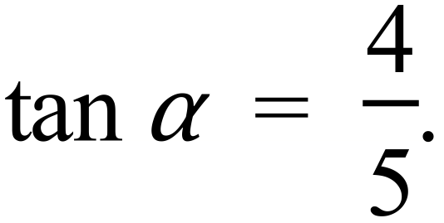
Answer to the nearest degree.

……………………………………………………………………………………………....

……………………………………………………………………………………………….
What is the length of the interval AG in the rectangular prism shown?
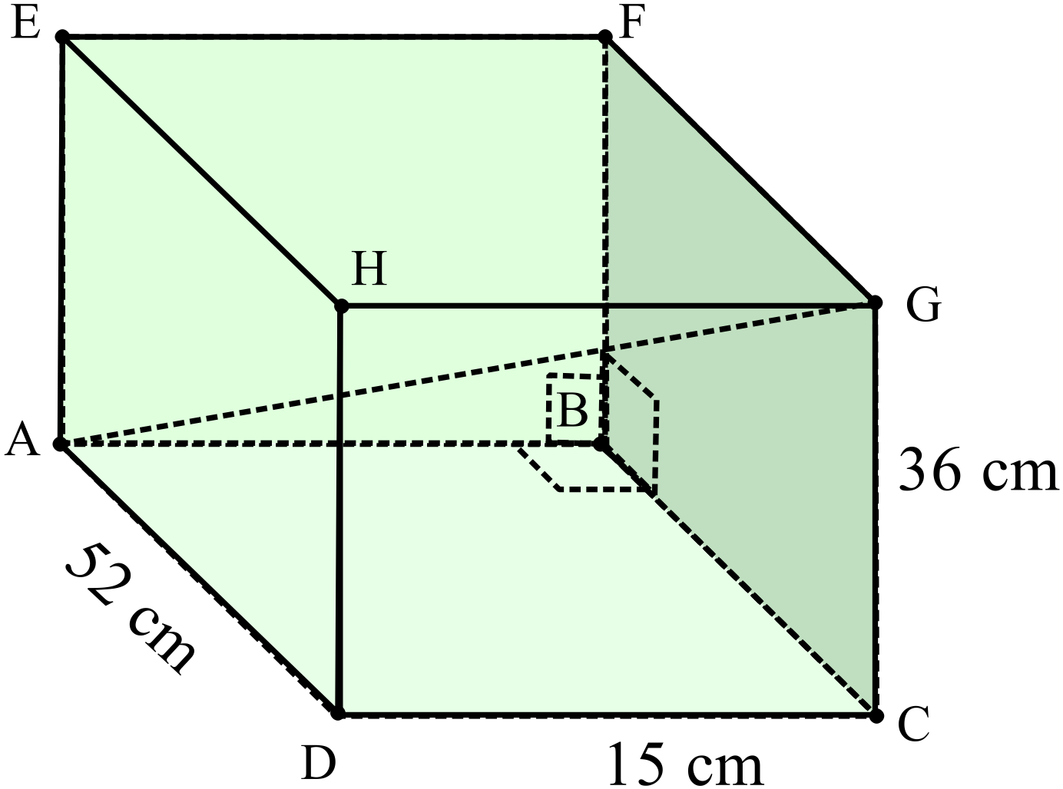

………………………………………………

………………………………………………

……………………………………………....

………………………………………………

……………………………………………….
From the top of a tower (T) the angles of depression of two points A and B are 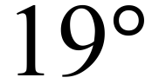 and 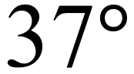 respectively.
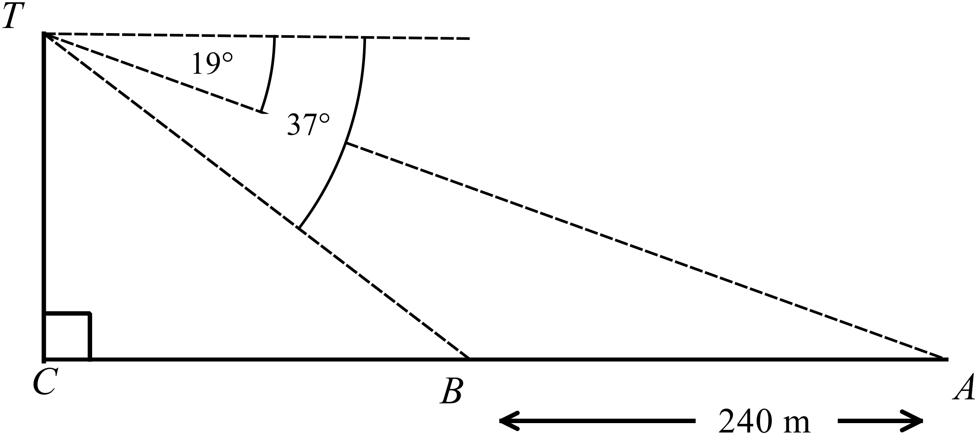If A and B are 240 m apart in a direct line to the base of the tower, calculate the distance BT, correct to the nearest metre.

………………………………………………………………………………………….……………

…………………………………………………………………………………….………………....

………………………………………………………………………………….……………………

……………………………………………………………………………………………………….
Find the length of  correct to the nearest mm.

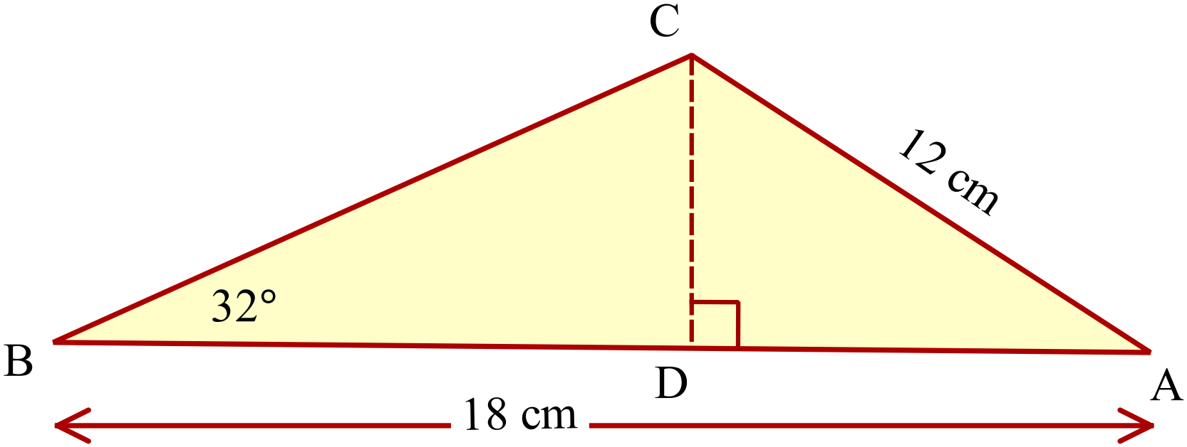
…………………………………………..

…………………………………….........

………………………………………………

……………………………………………….
Two planes leave airports M and N at the same time, both flying to a third airport O.
The plane leaving M flies on a bearing of 114º and the plane from N flies on a bearing of 055º.
M is 1 125 km due north of N.
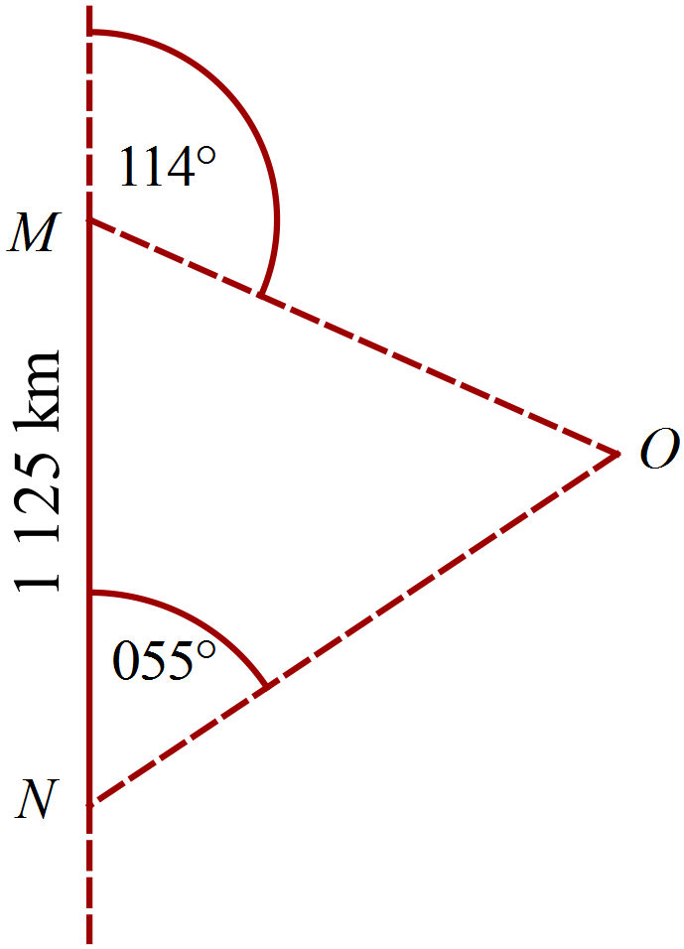How far is O from M?

……………………………………………....

………………………………………………

……………………………………………....

………………………………………………

……………………………………………….
Use the table below to sketch

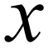 | 0 | 30 | 60 | 90 | 120 | 150 | 180 | 210 | 240 | 270 | 300 | 330 | 360
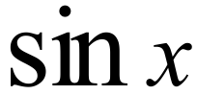 | 0.00 | 0.50 | 0.87 | 1.00 | 0.87 | 0.50 | 0.00 | -0.50 | -0.87 | -1.00 | -0.87 | -0.50 | 0.00
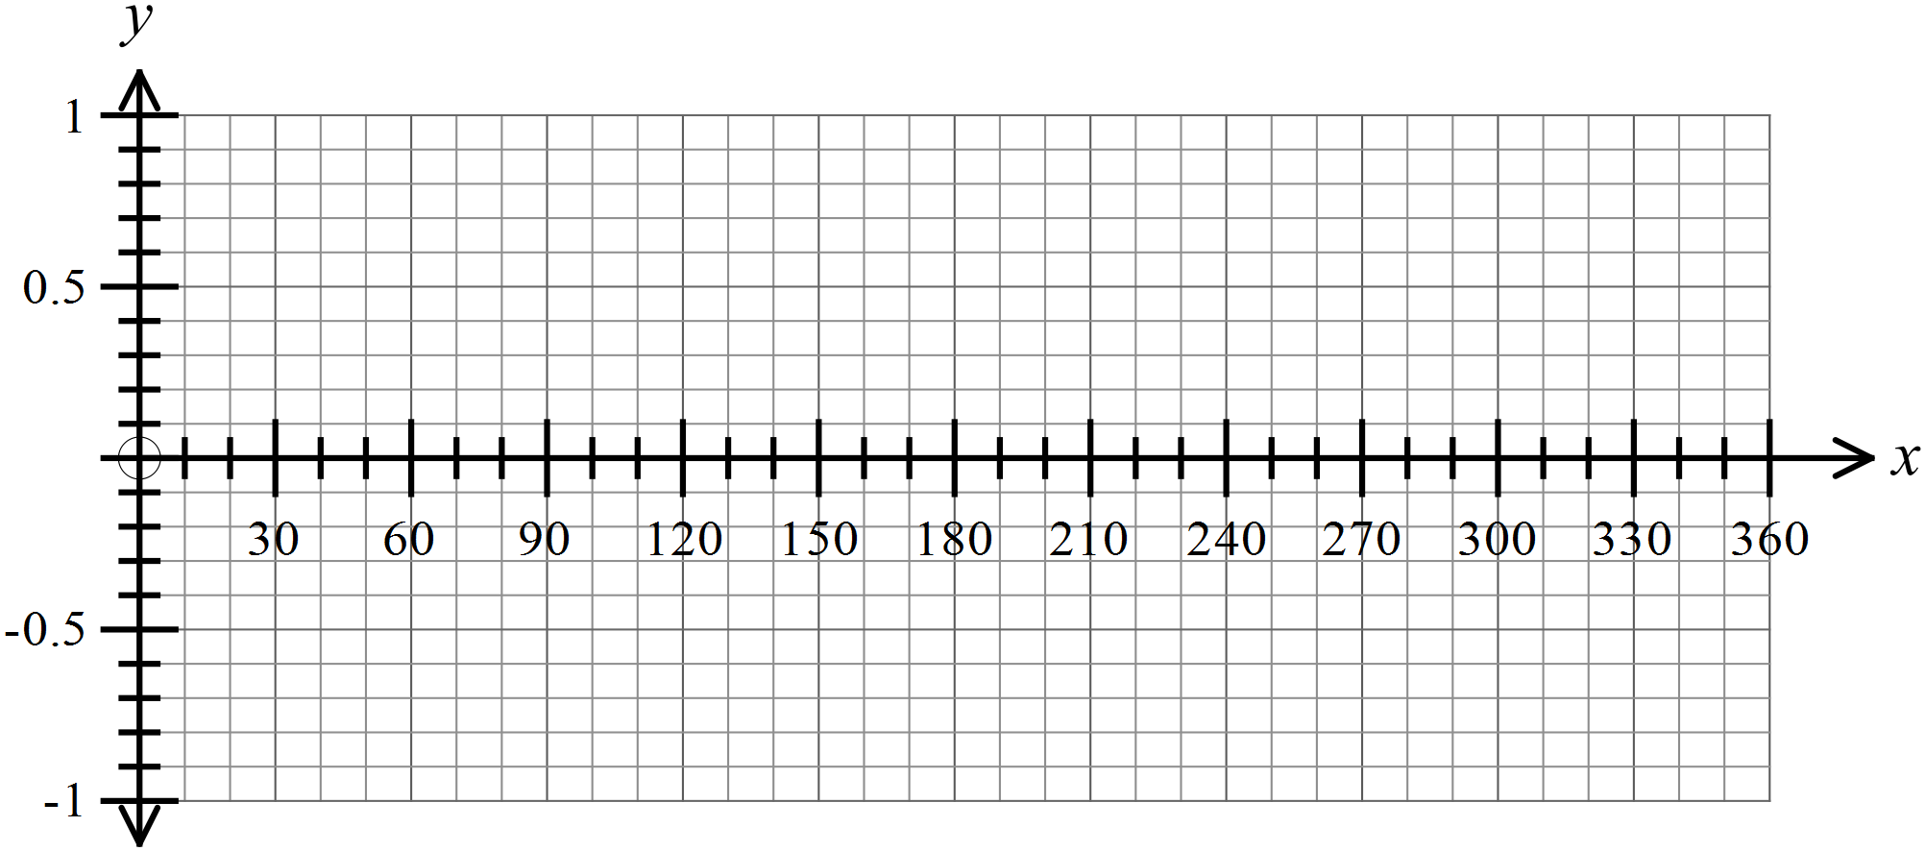

Year 10 |  | Non Right Triangle Trigonometry | Calculator Allowed
 |  | Non Right Triangle Trigonometry | Name_________________
Section 2 Multiple Choice Section
Mark all your answers on the accompanying multiple choice answer sheet, not on this test paper. You may do any working out on this test paper. Calculators are allowed for this section.

Which statement of the cosine rule could be used to find 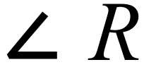 in ∆PQR?

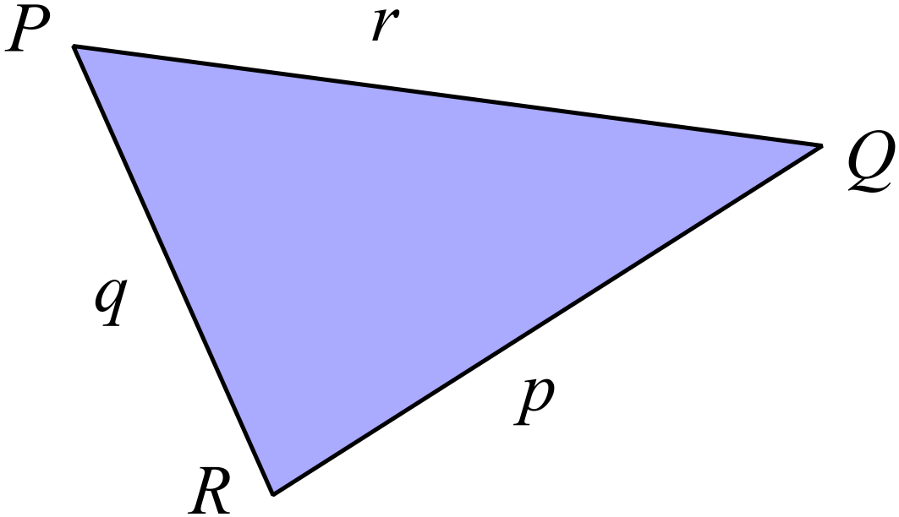 A. 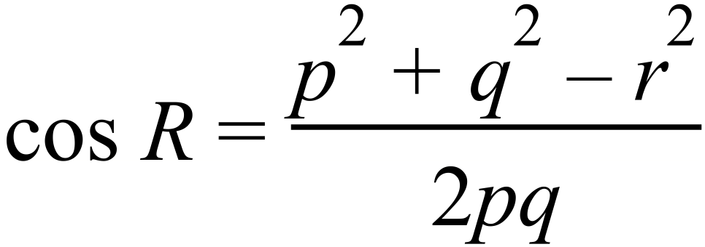
B. 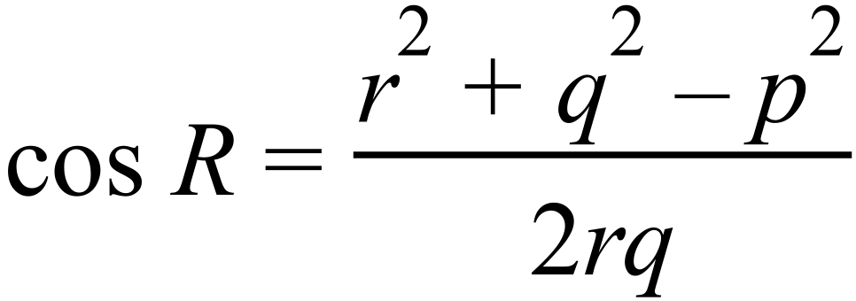
C. 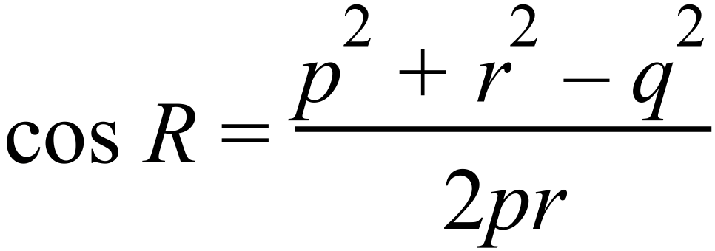
D. 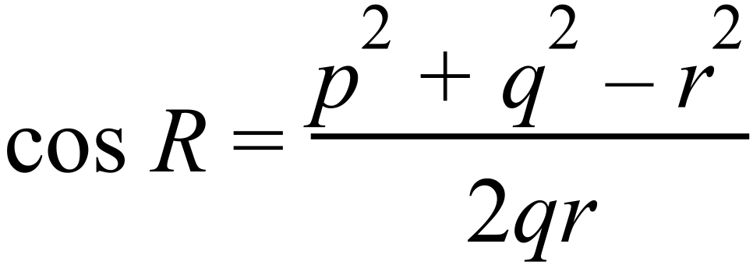
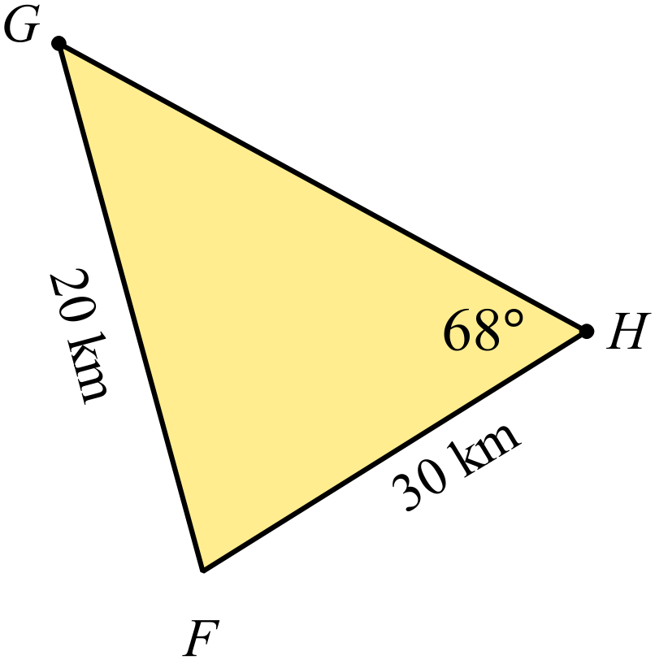Which calculation using the sine rule could be used to find the size of 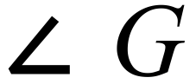 ?

A. 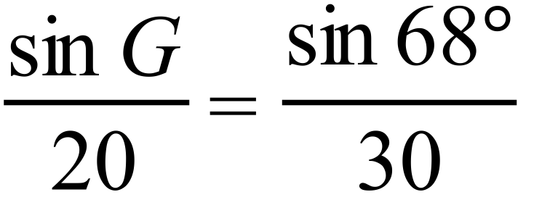 B. 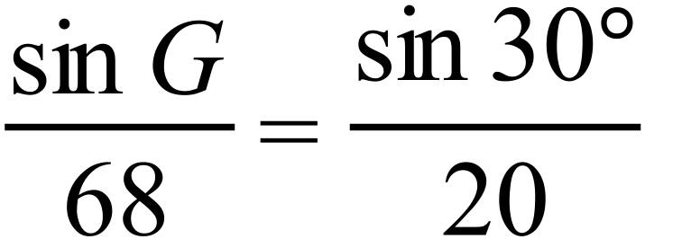
C. 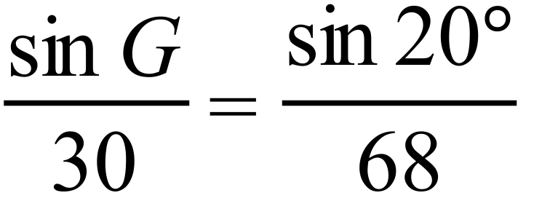 D. 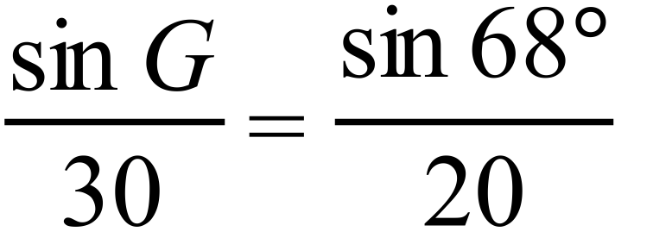

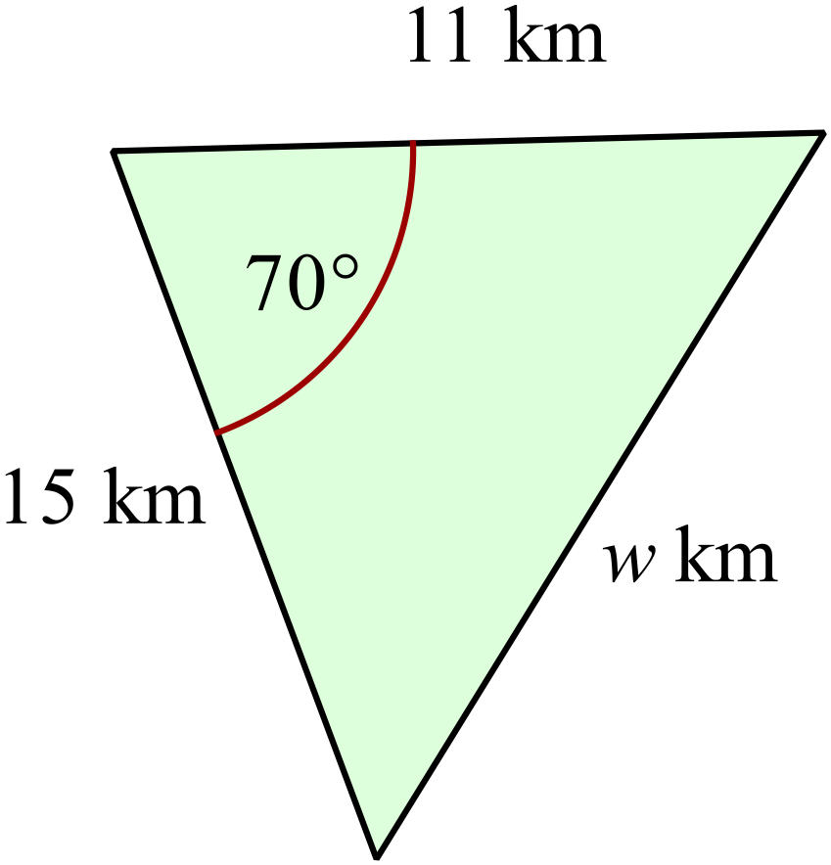Use the cosine rule to find the value of w, correct to 1 decimal place.

A. 8.0
B. 15.3
C. 17.0
D. 21.4

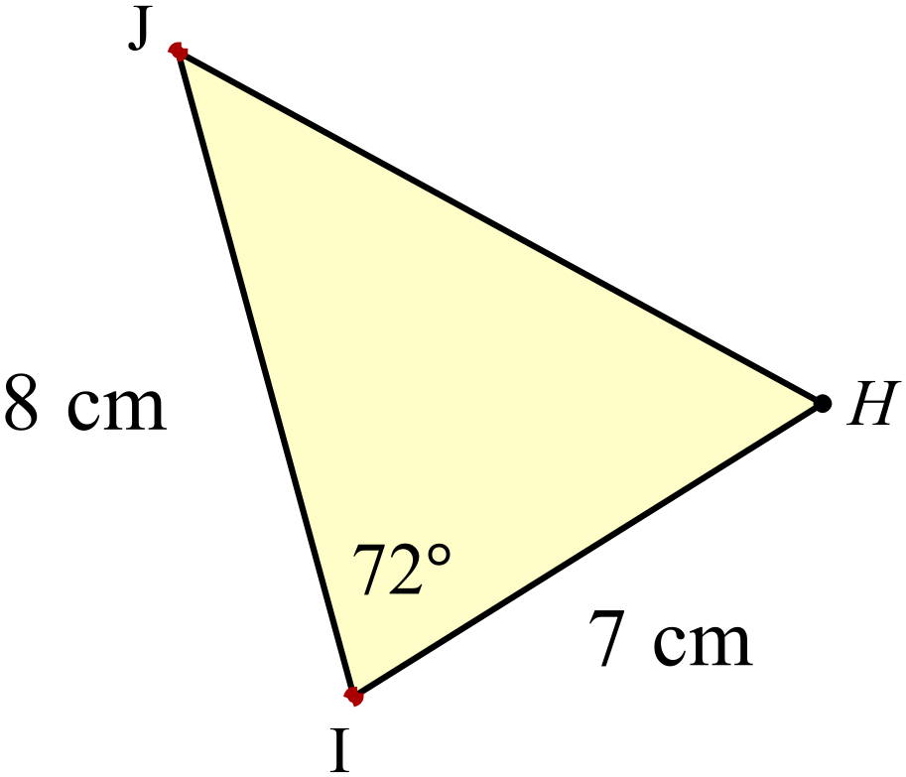Use the area formula to find the area of 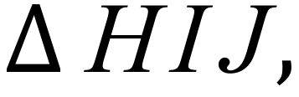 correct to the nearest 10th of a square cm.
A. 19.2 cm²
B. 26.6 cm²
C. 53.3 cm²
D. 63.5 cm²

Solve

A. 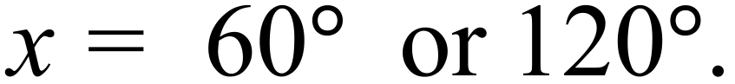 B. 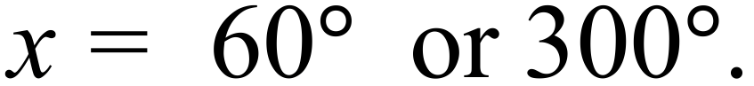
C. 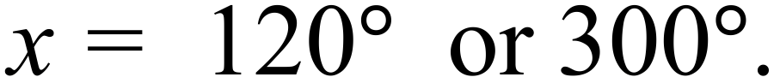 D. 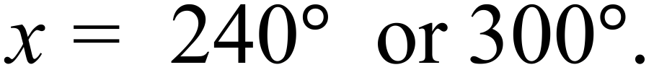
Calculate the value of 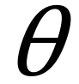 correct to the nearest degree.
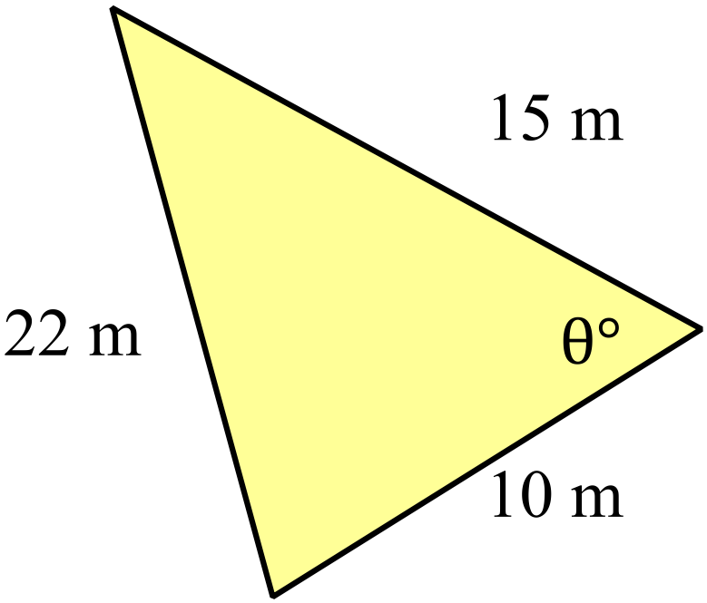

A. 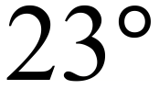
B. 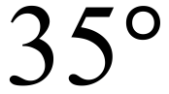
C. 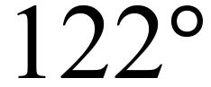
D. 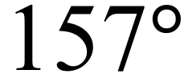

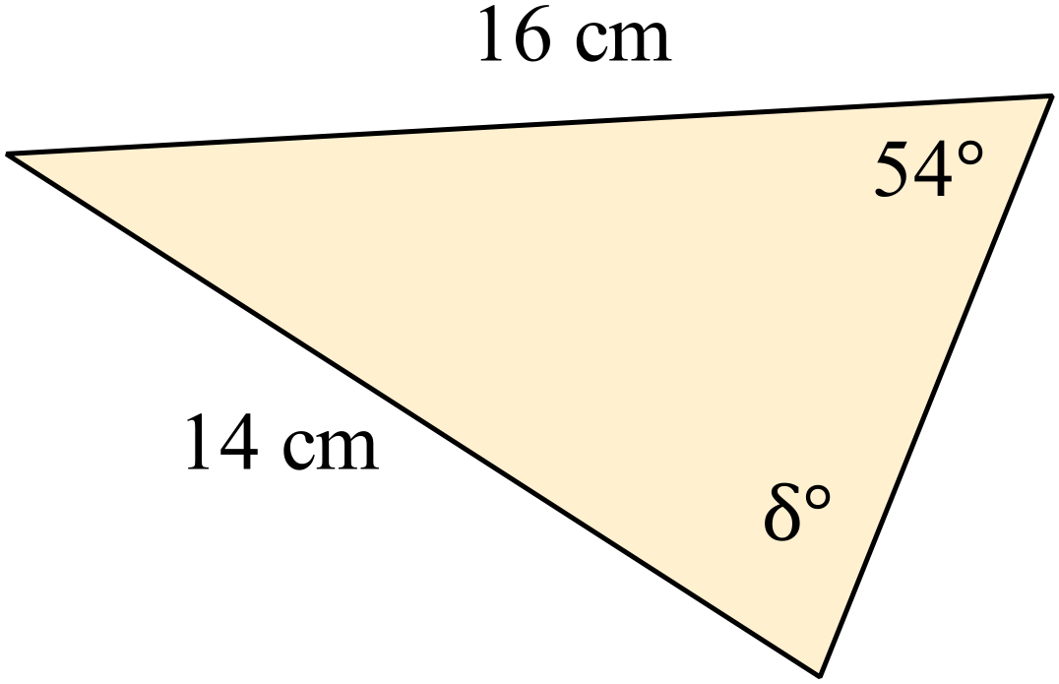Find the value of 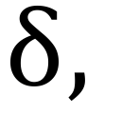 to the nearest degree.

A. 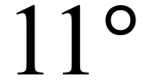
B. 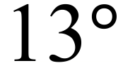
C. 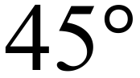
D. 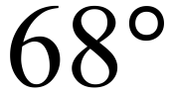

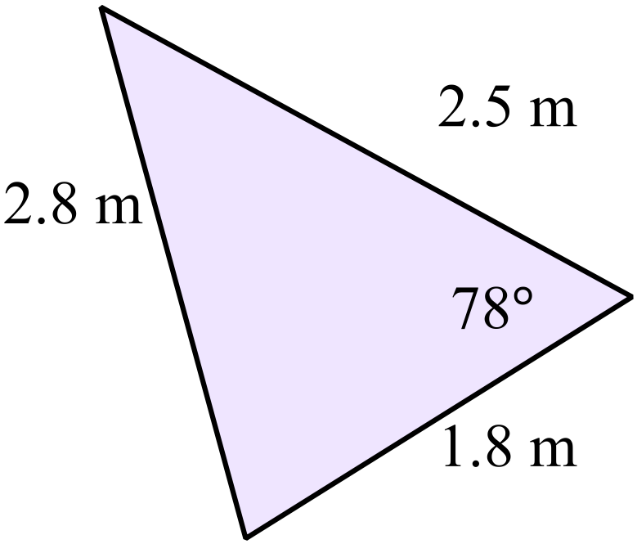Find the area of the triangle shown correct to 1 decimal place.

A. 2.2 m²
B. 2.5 m²
C. 3.4 m²
D. 4.4 m²

The direct distance from ship A to the lighthouse L is 4.2 km and from ship B to the lighthouse is 3.8 km.
The two ships are in a straight line to the lighthouse and are 1.6 km apart.
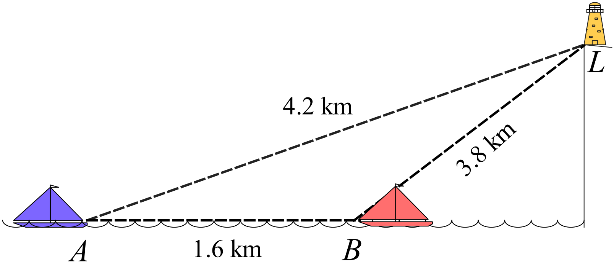What is the angle of elevation of the lighthouse from ship A?

A. 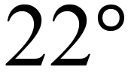
B.
C. 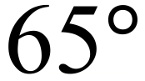
D. 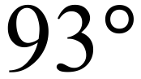

An equilateral triangle is shown with the perpendicular bisector of one side drawn in.
Use the equilateral triangle to find the exact value of 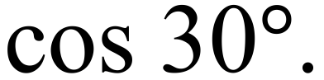
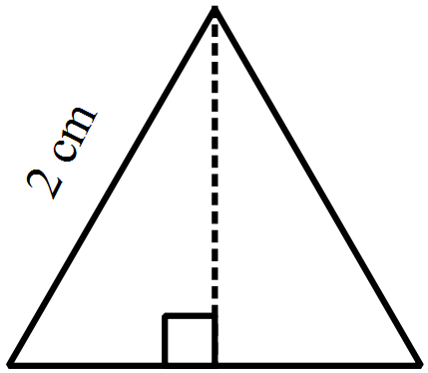
A. 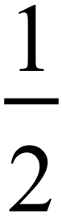
B. 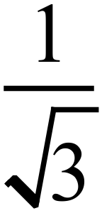
C. 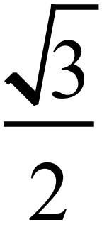
D. 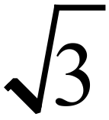

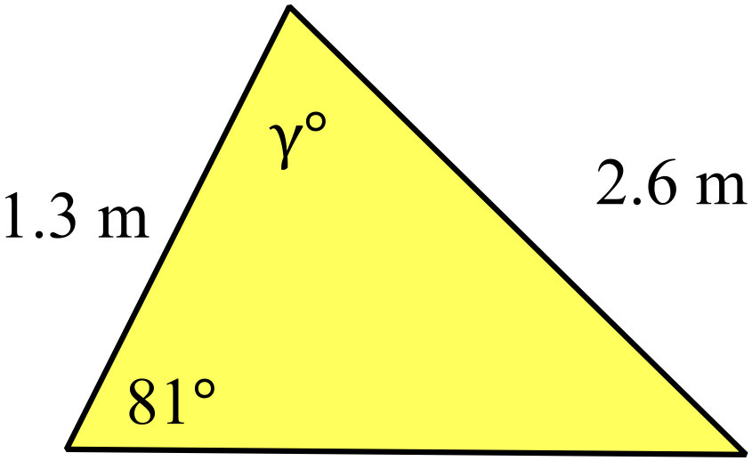Find the value of 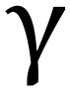 correct to the nearest degree.

A. 30º
B. 69º
C. 111º
D. 150º

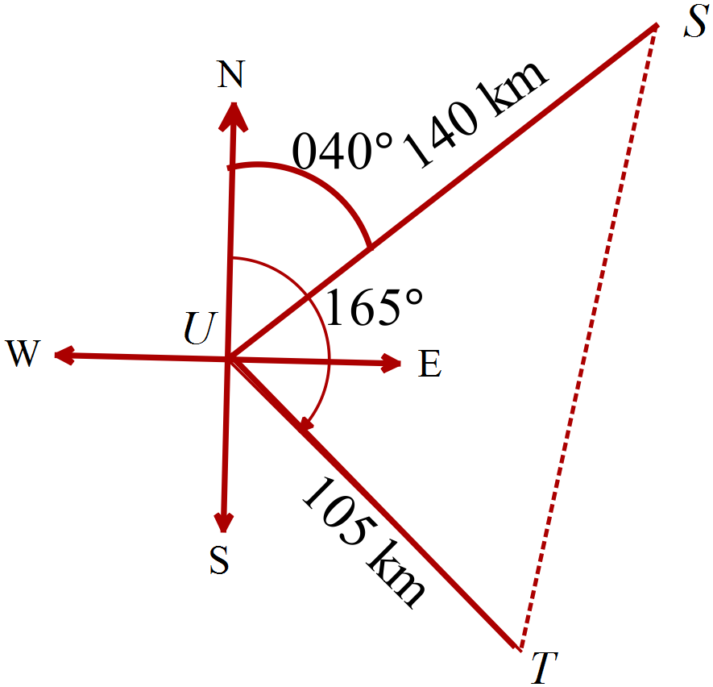Ship S is 140 km on a bearing of 040º from Port U.
Ship T is 105 km on a bearing of 165º from Port U.
Calculate the distance ST, correct to the nearest 10th of a kilometre.

A. 117.3 km
B. 197.6 km
C. 217.9 km
D. 242.9 km

Which graph shows a sketch of 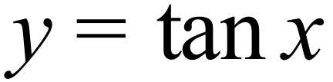 for 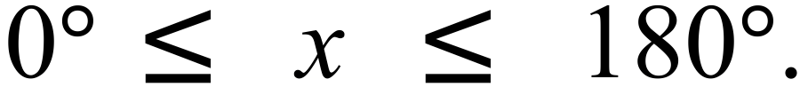

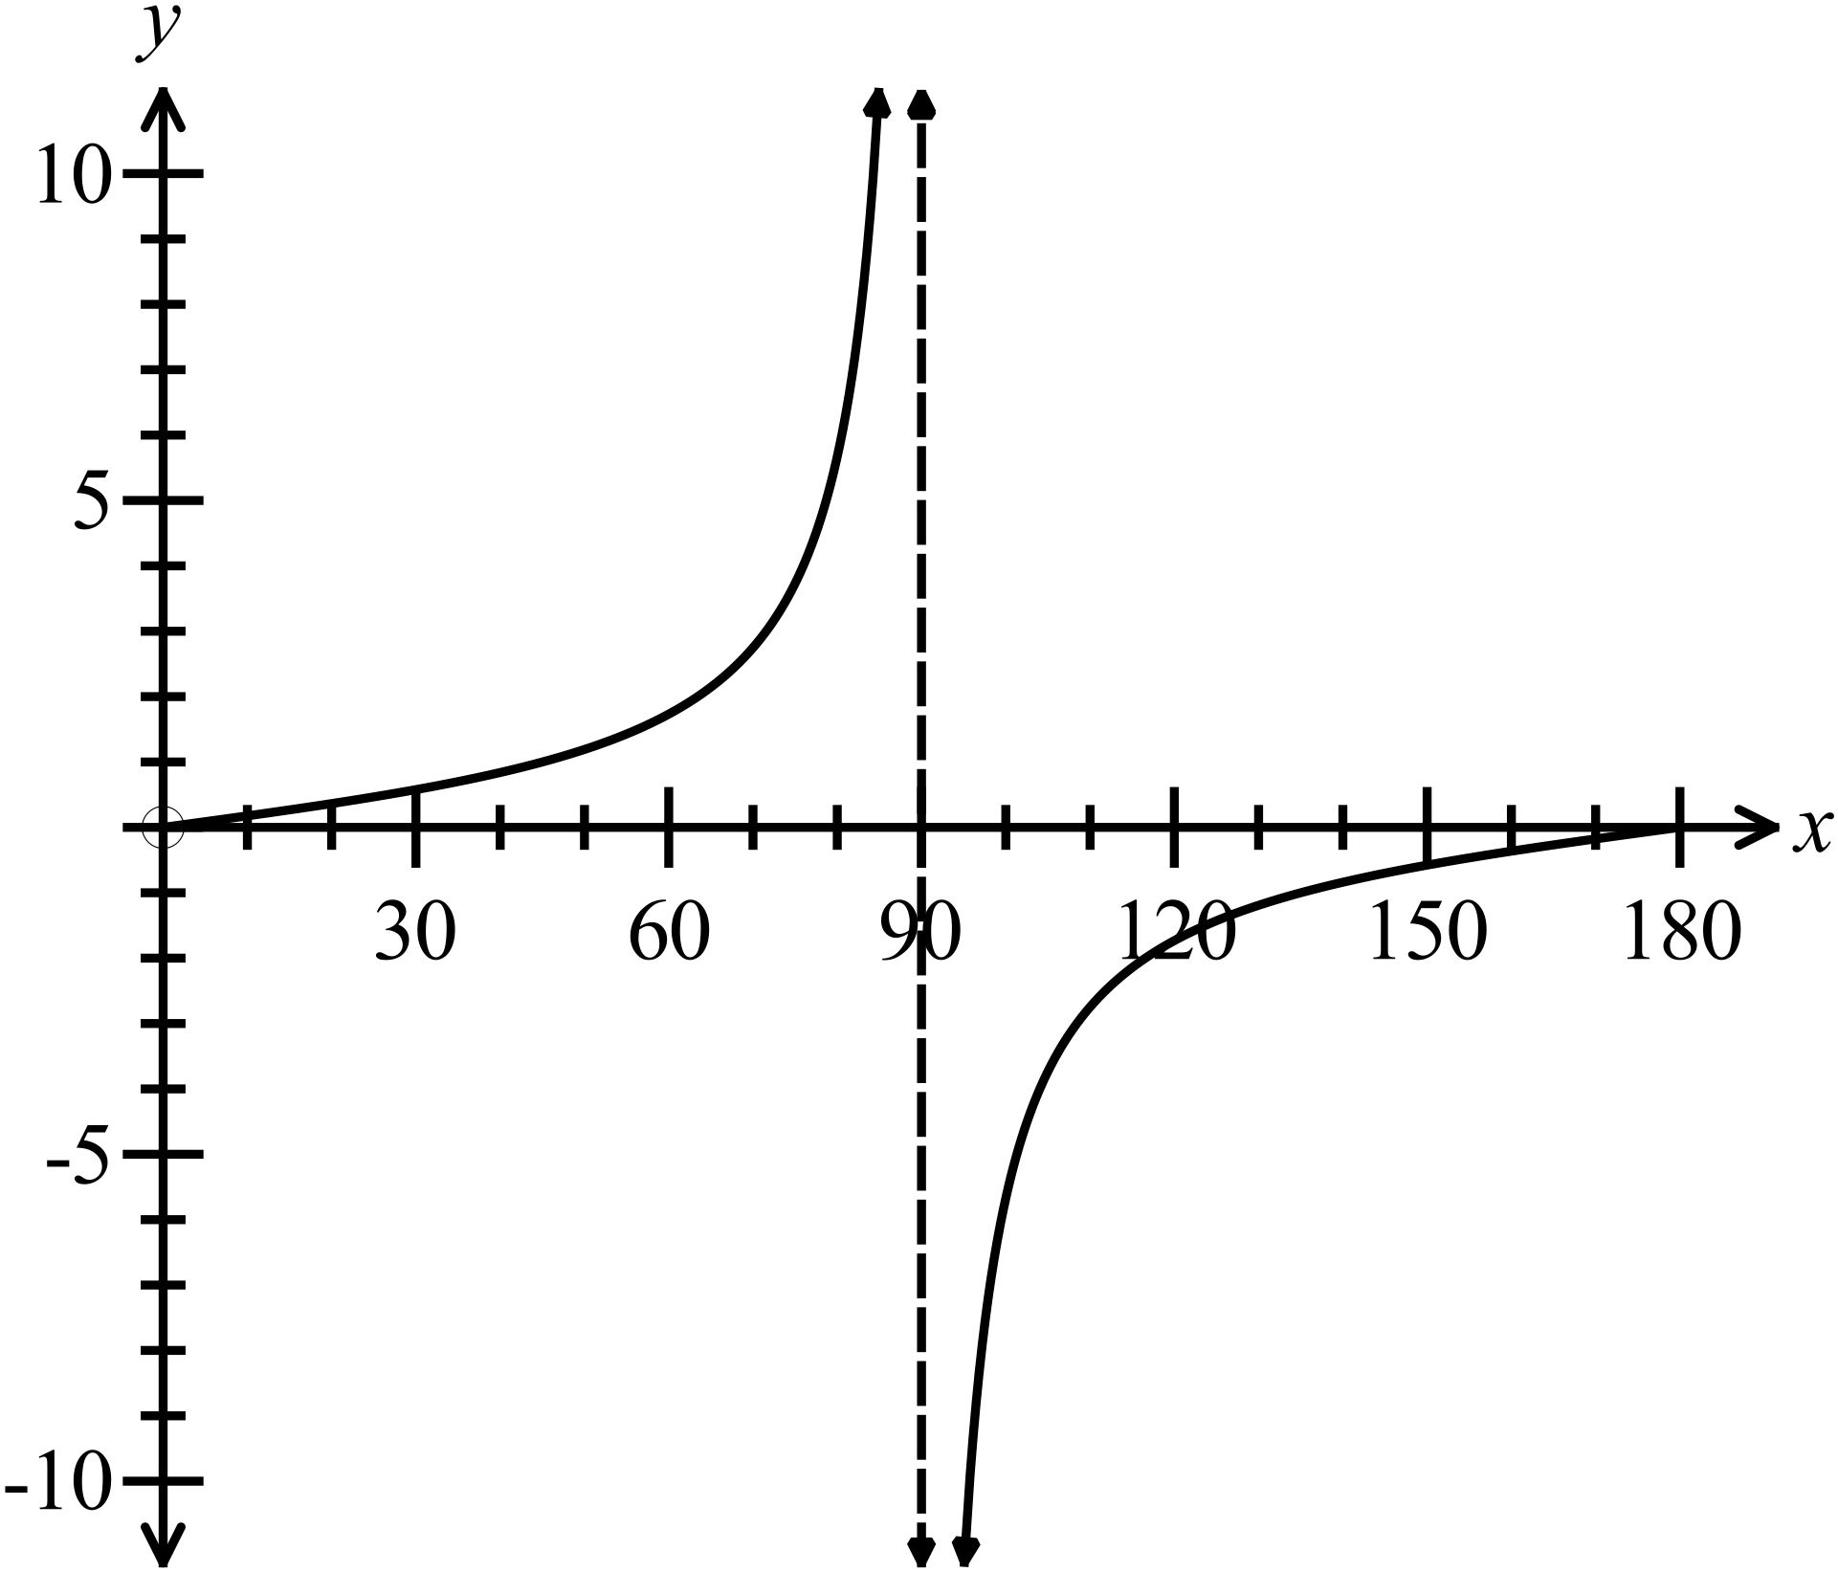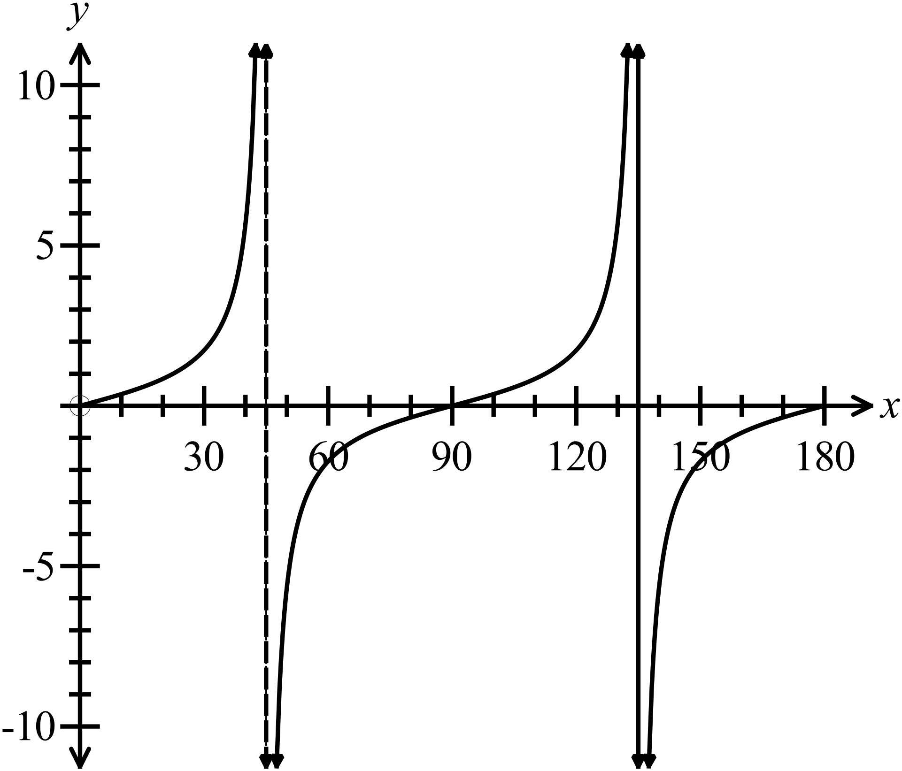
A. B.

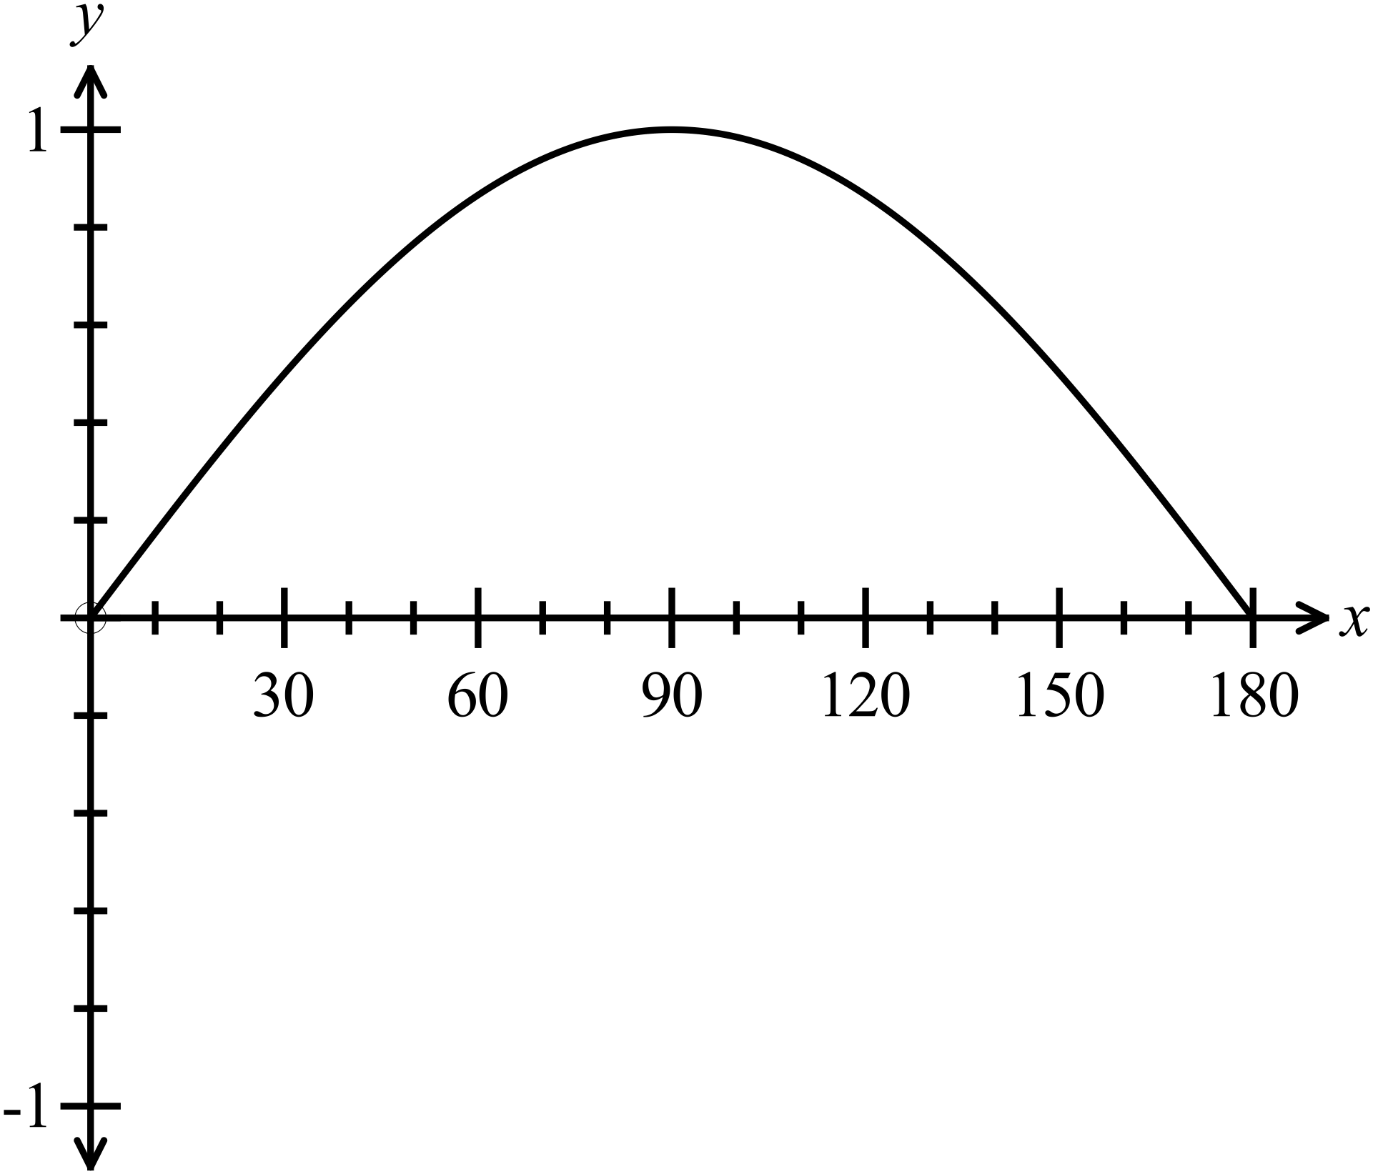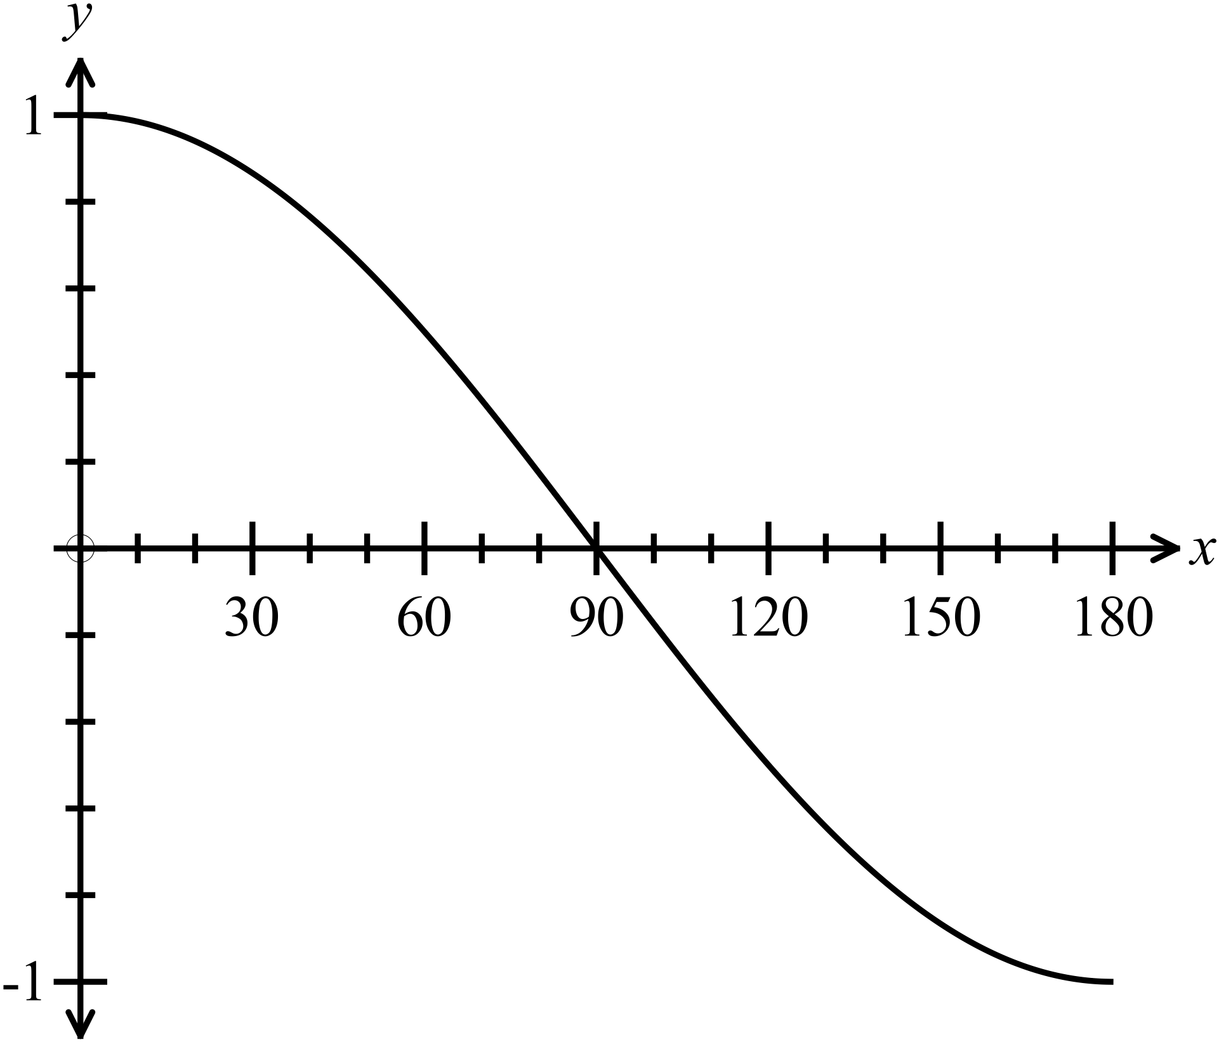 C. D.

If 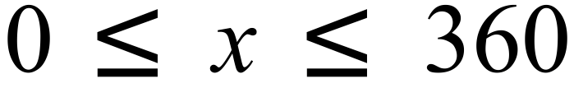; for what values of x is 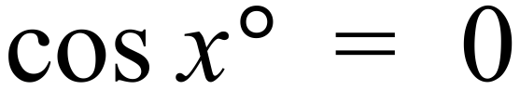?
A. 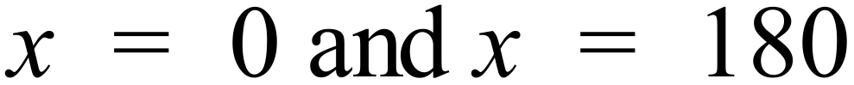
B. 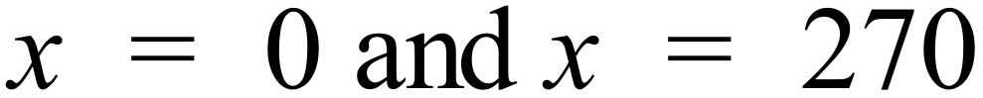
C.
D.
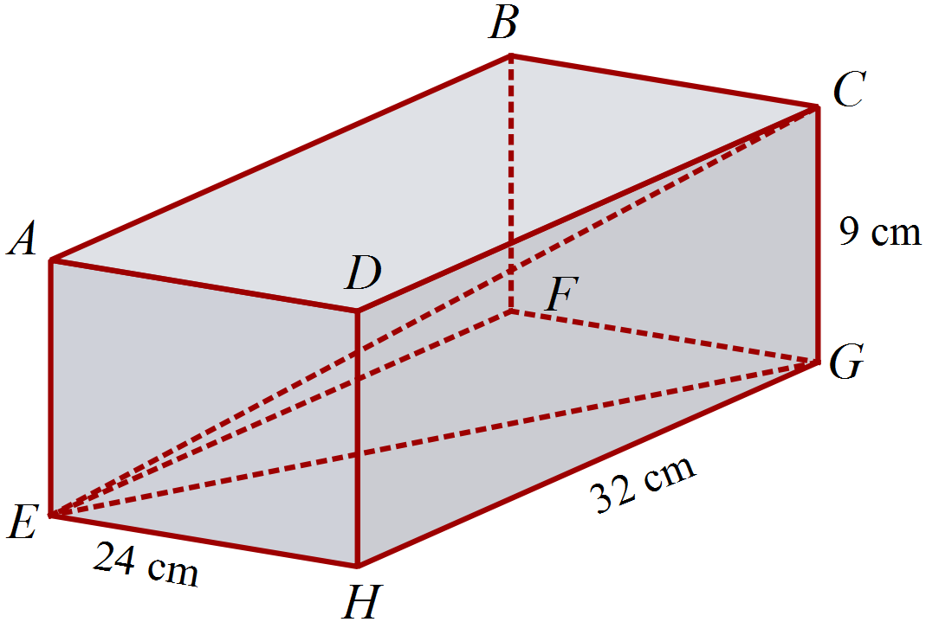The rectangular prism shown measures 24 cm by 32 cm by 9 cm.
What is the size of 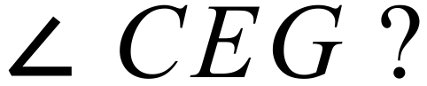

A.
B. 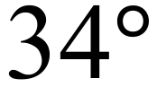
C. 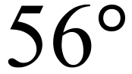
D. 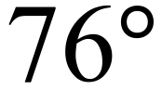

Multiple Choice Answer Sheet
Non Right Triangle Trigonometry
Name _____________________________________________
Completely fill the response oval representing the most correct answer.

1. A B C D
2. A B C D
3. A B C D
4. A B C D
5. A B C D
6. A B C D
7. A B C D
8. A B C D
9. A B C D
10. A B C D
11. A B C D
12. A B C D
13. A B C D
14. A B C D
15. A B C D
Year 10 |  | Non Right Triangle Trigonometry | Calculator
Section 1 Short Answer Section
ANSWERS
No. | WORKING |  | ANSWER
 | 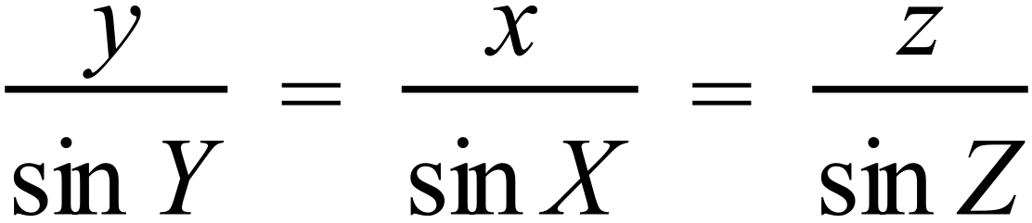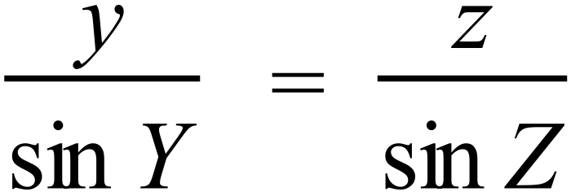  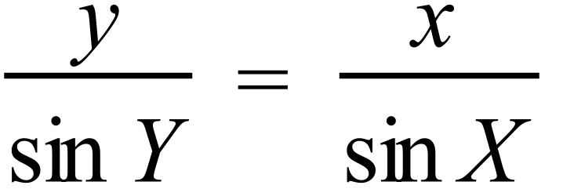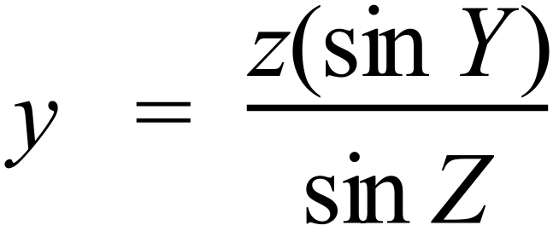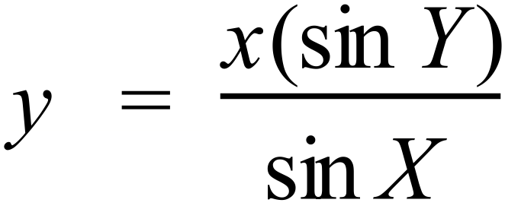 |  | Any of the equations shown at left.
 | 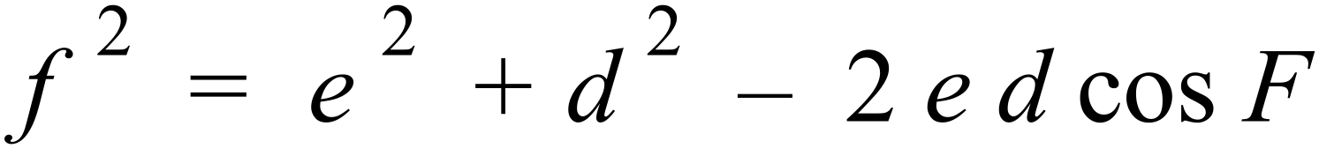
 | 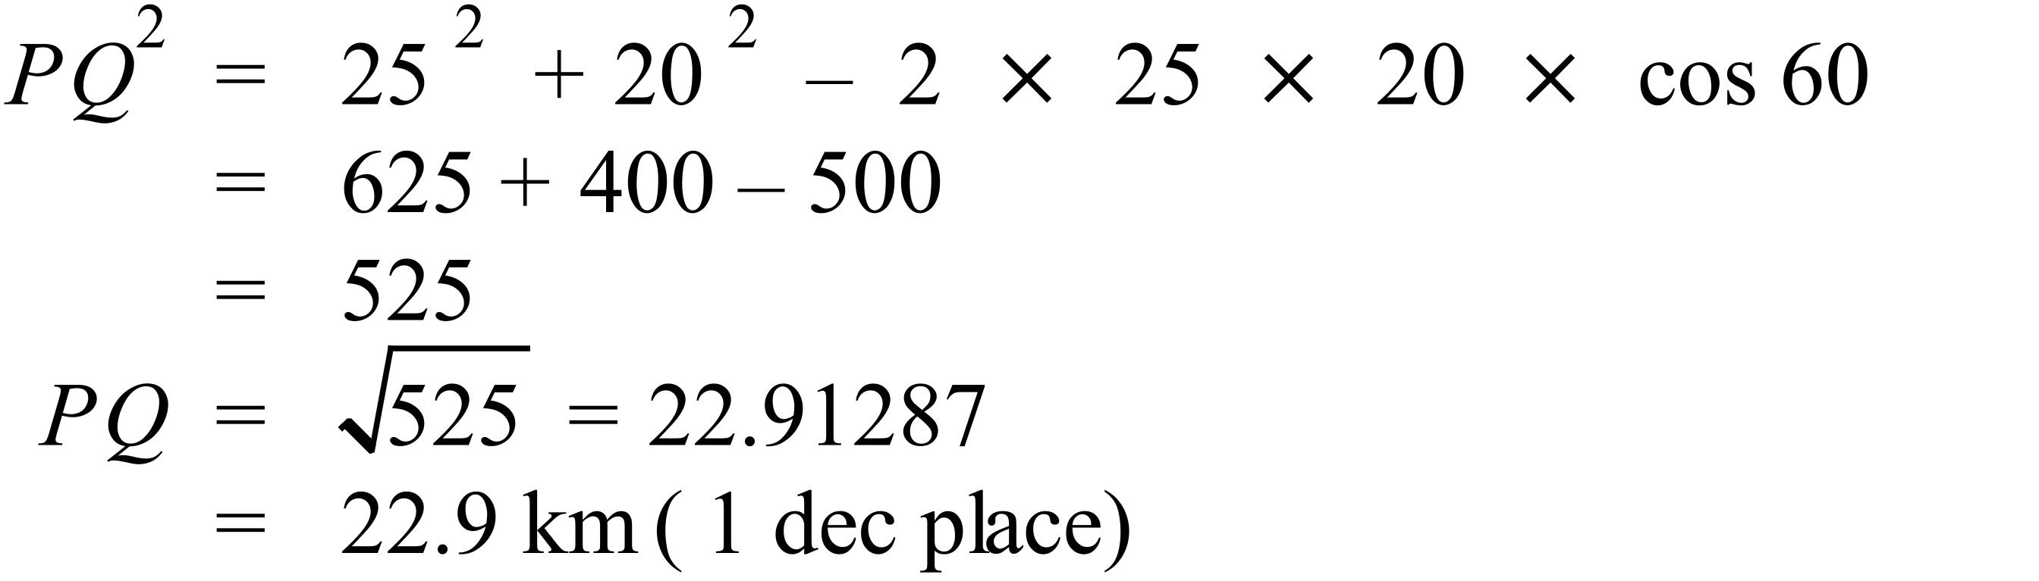 |  | 22.9 km
 | 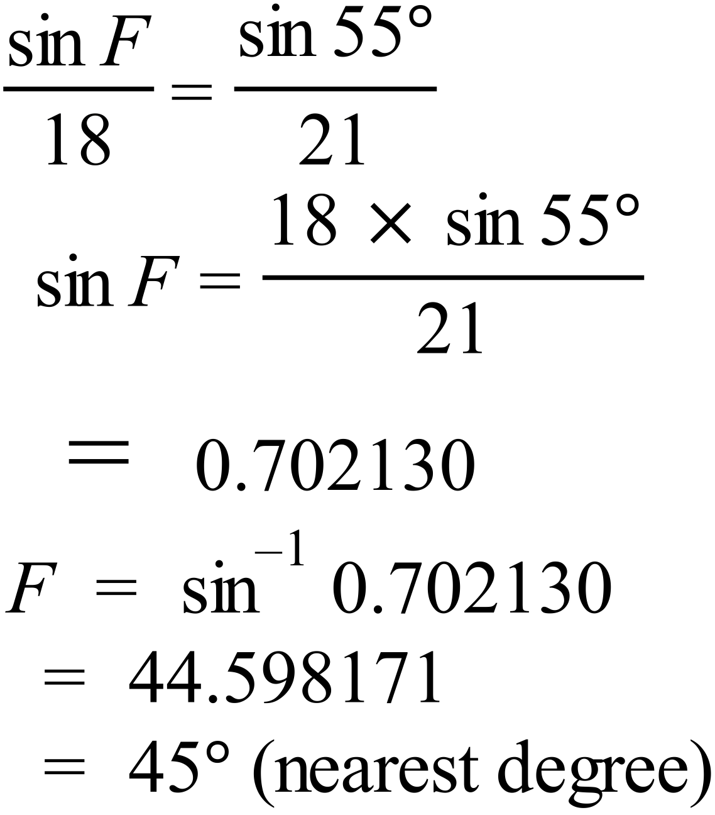
 | 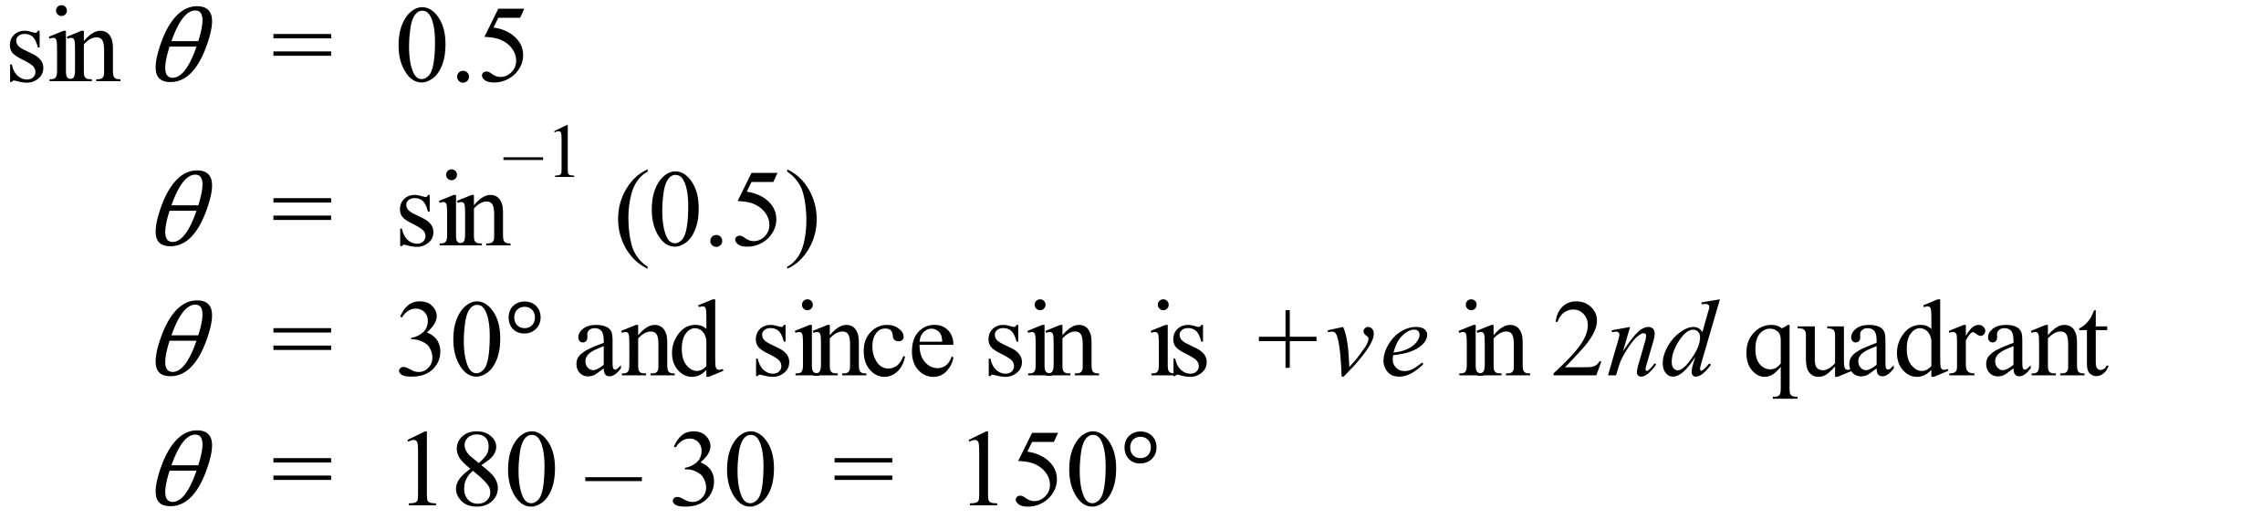 |  | 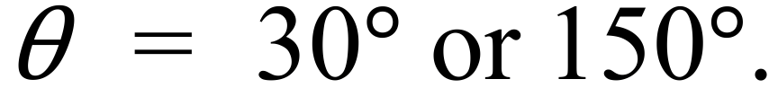
 | 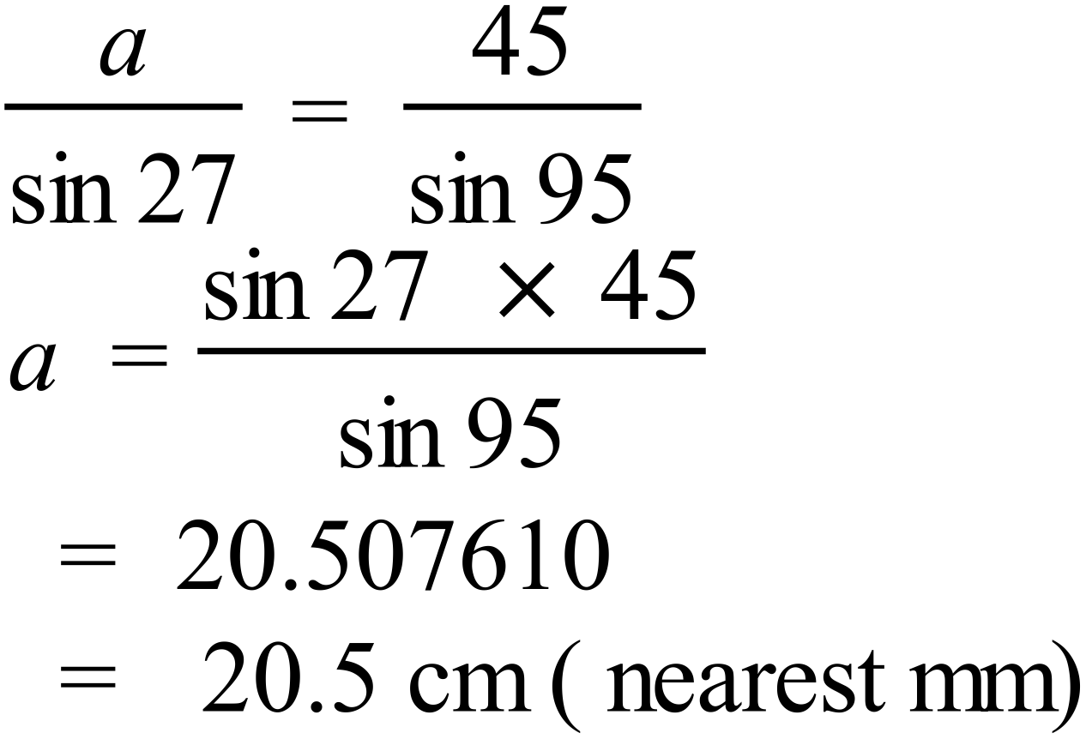 |  | 20.5 cm  or 205 mm
 | 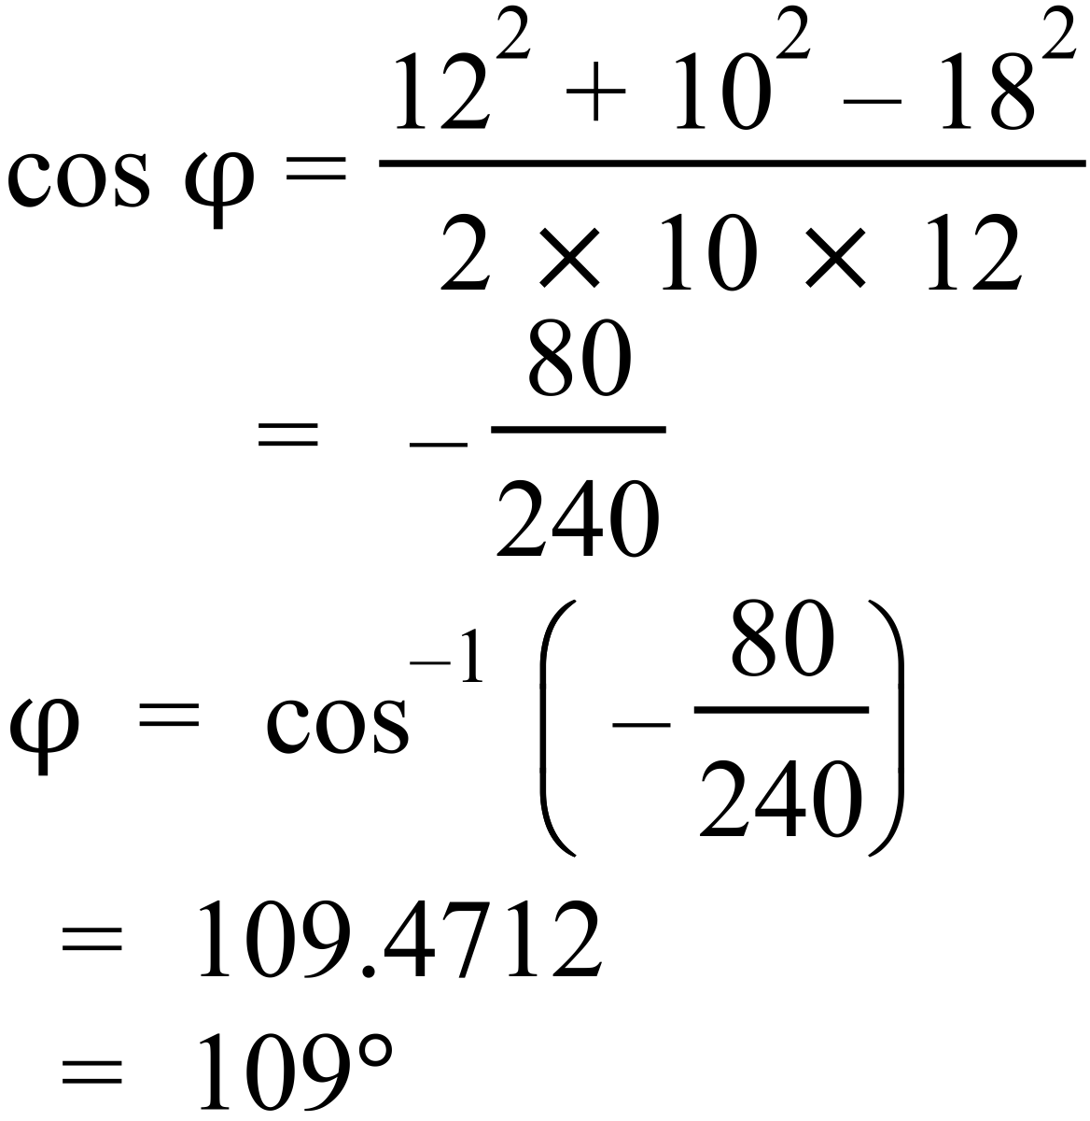 |  | 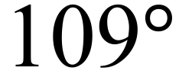
 | 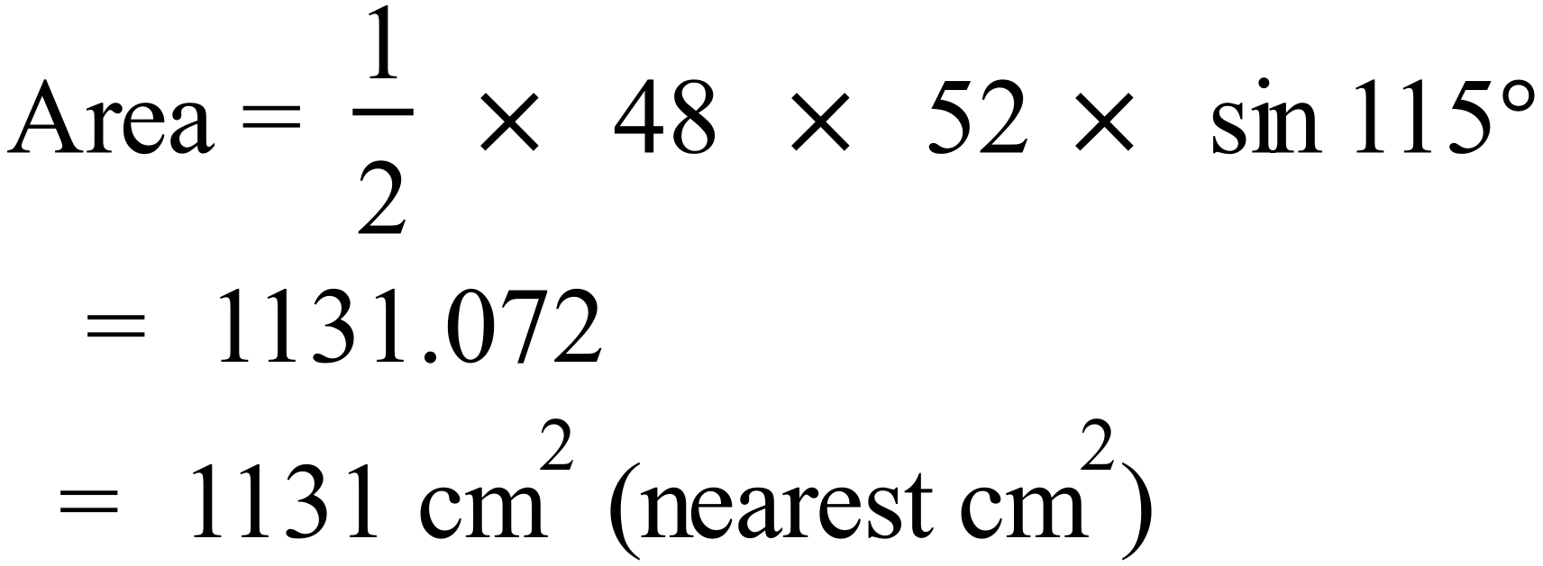 |  | 1131 cm²
 | 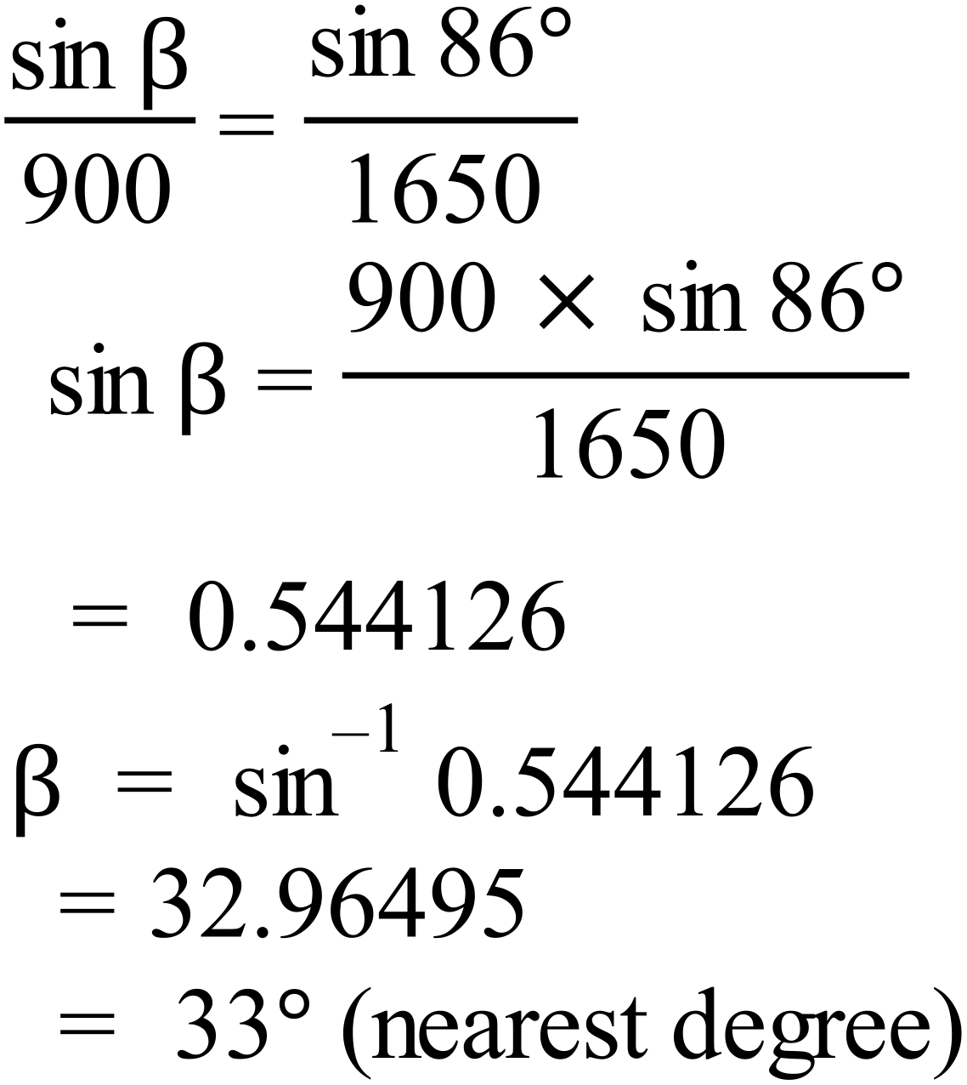 |  | 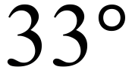
 | 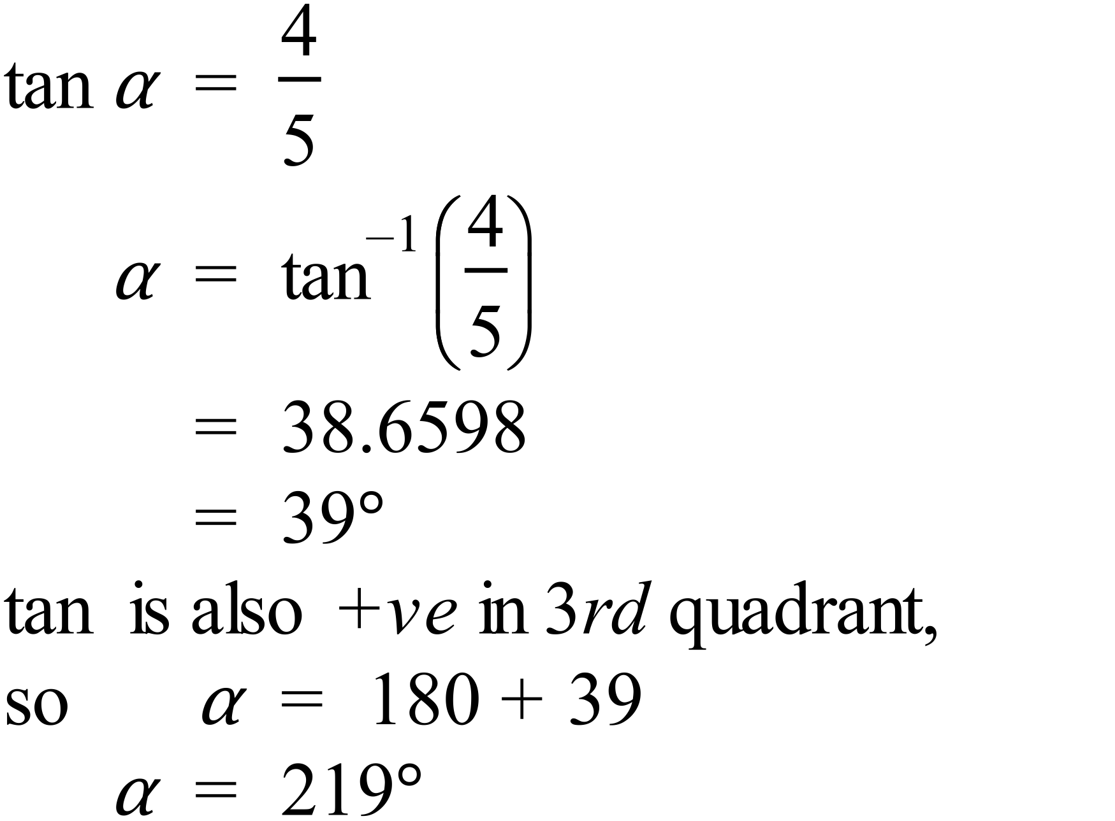 |  | 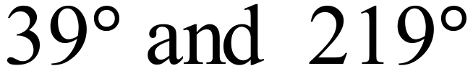
 | 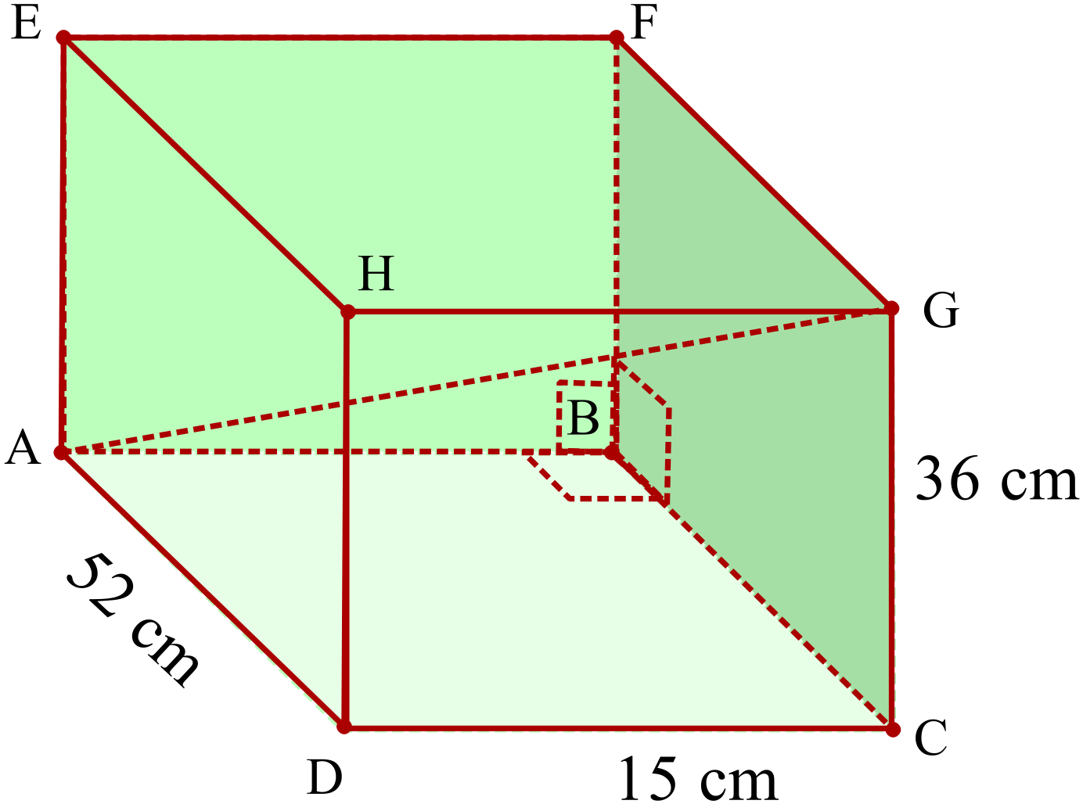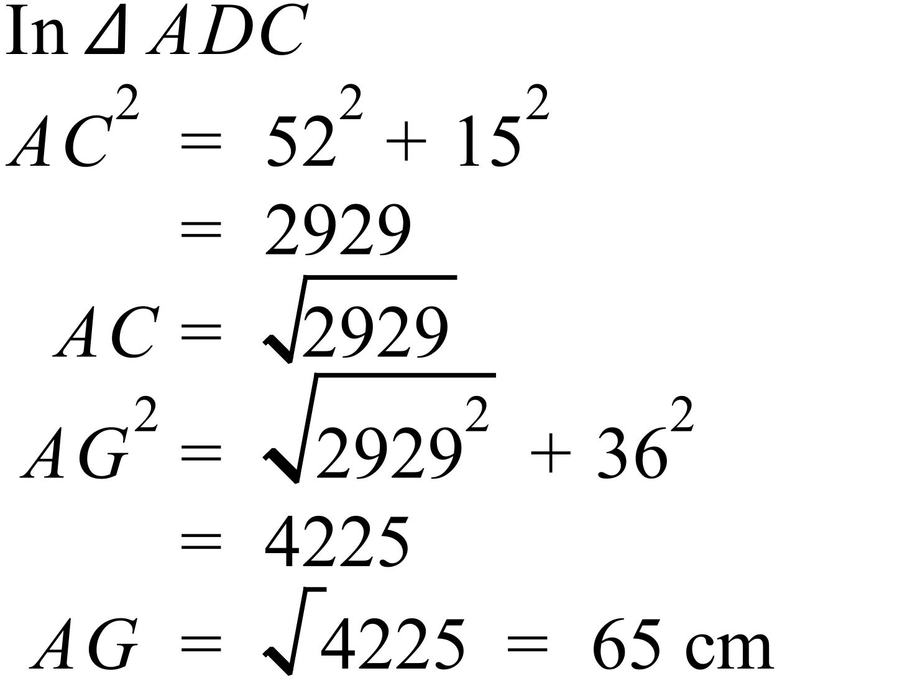 |  | 65 cm
 | 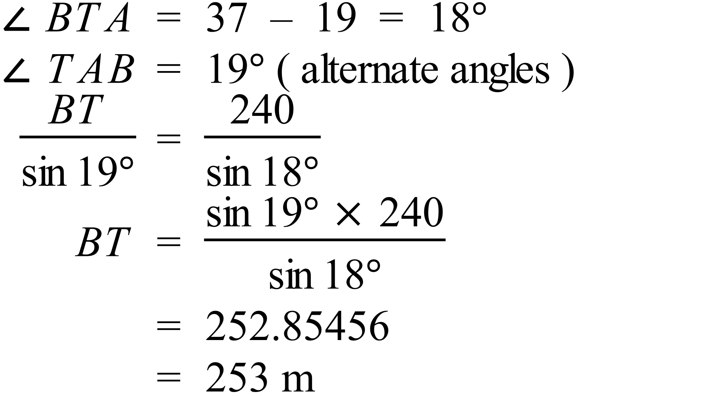 |  | 253 m
 | 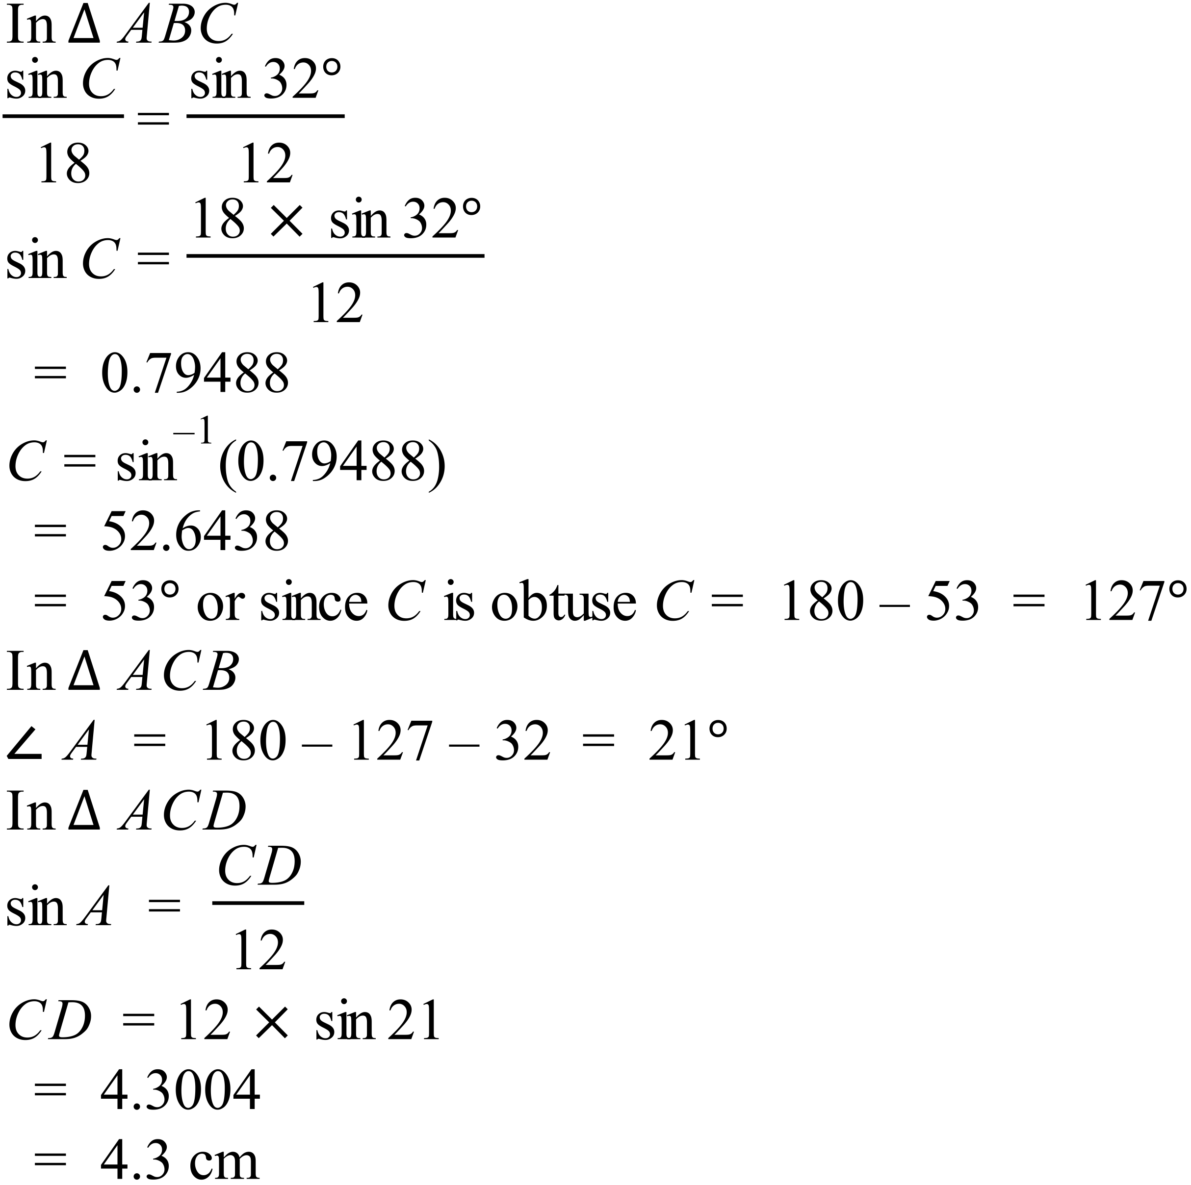 |  | 4.3 cm
 | 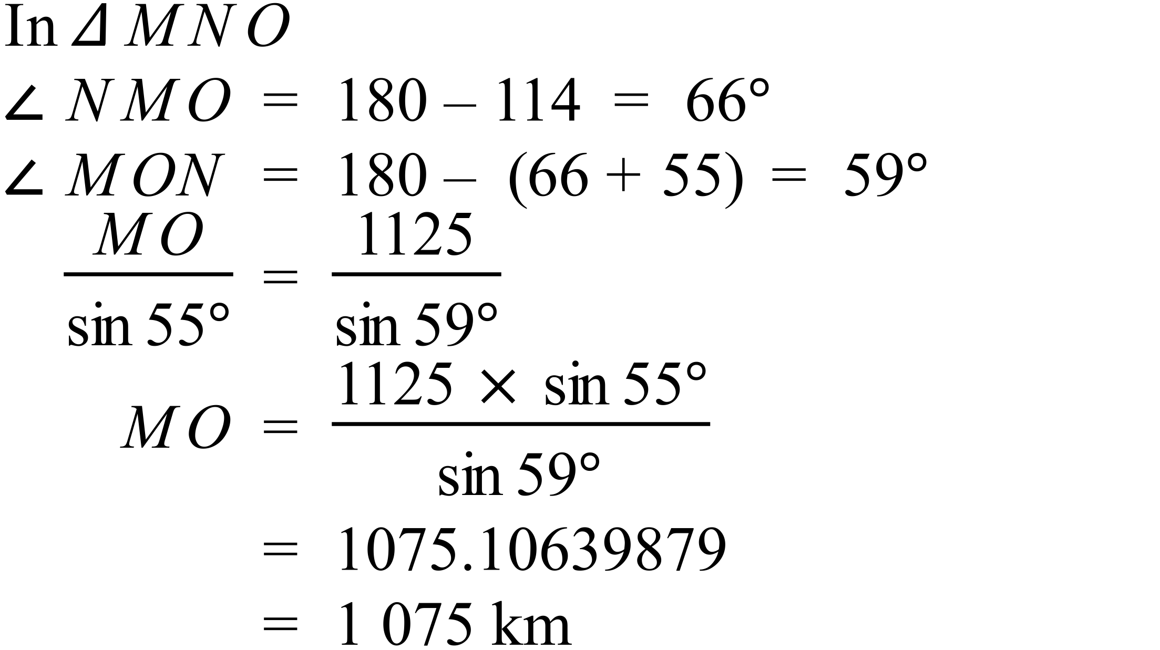 |  | 1 075 km
 | 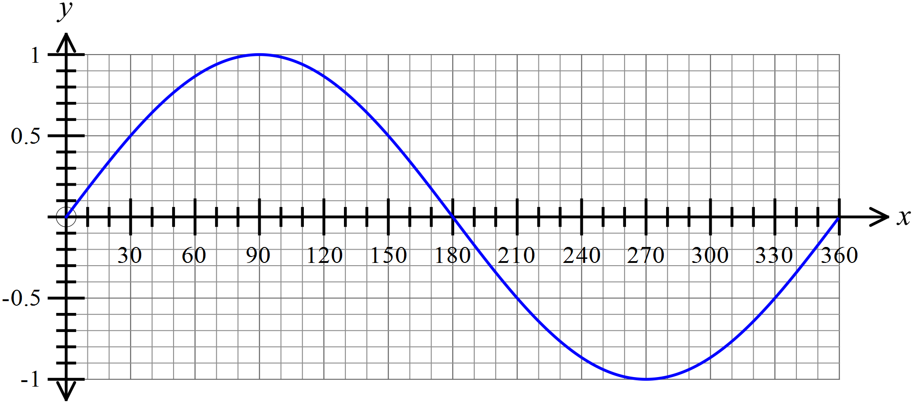

Year 10 |  | Non Right Triangle Trigonometry | Calculator Allowed
Section 2 Multiple Choice Section
ANSWERS
No. | WORKING |  |  | ANSWER
 |  |  |  | A
 |  |  |  | D
 | 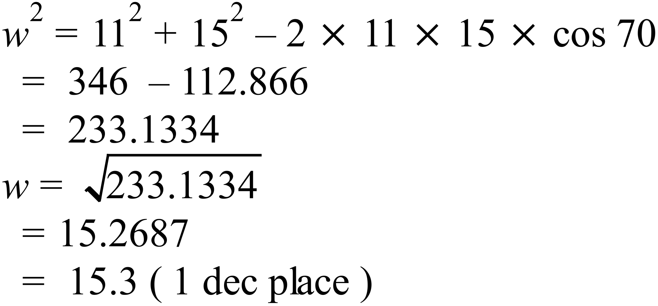 |  |  | B
 | 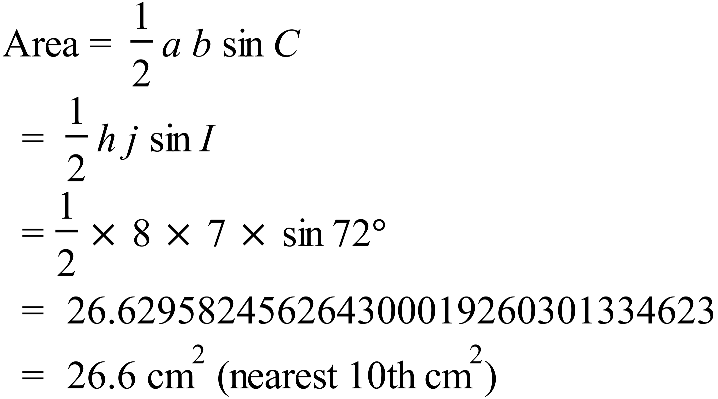 |  |  | B
 | 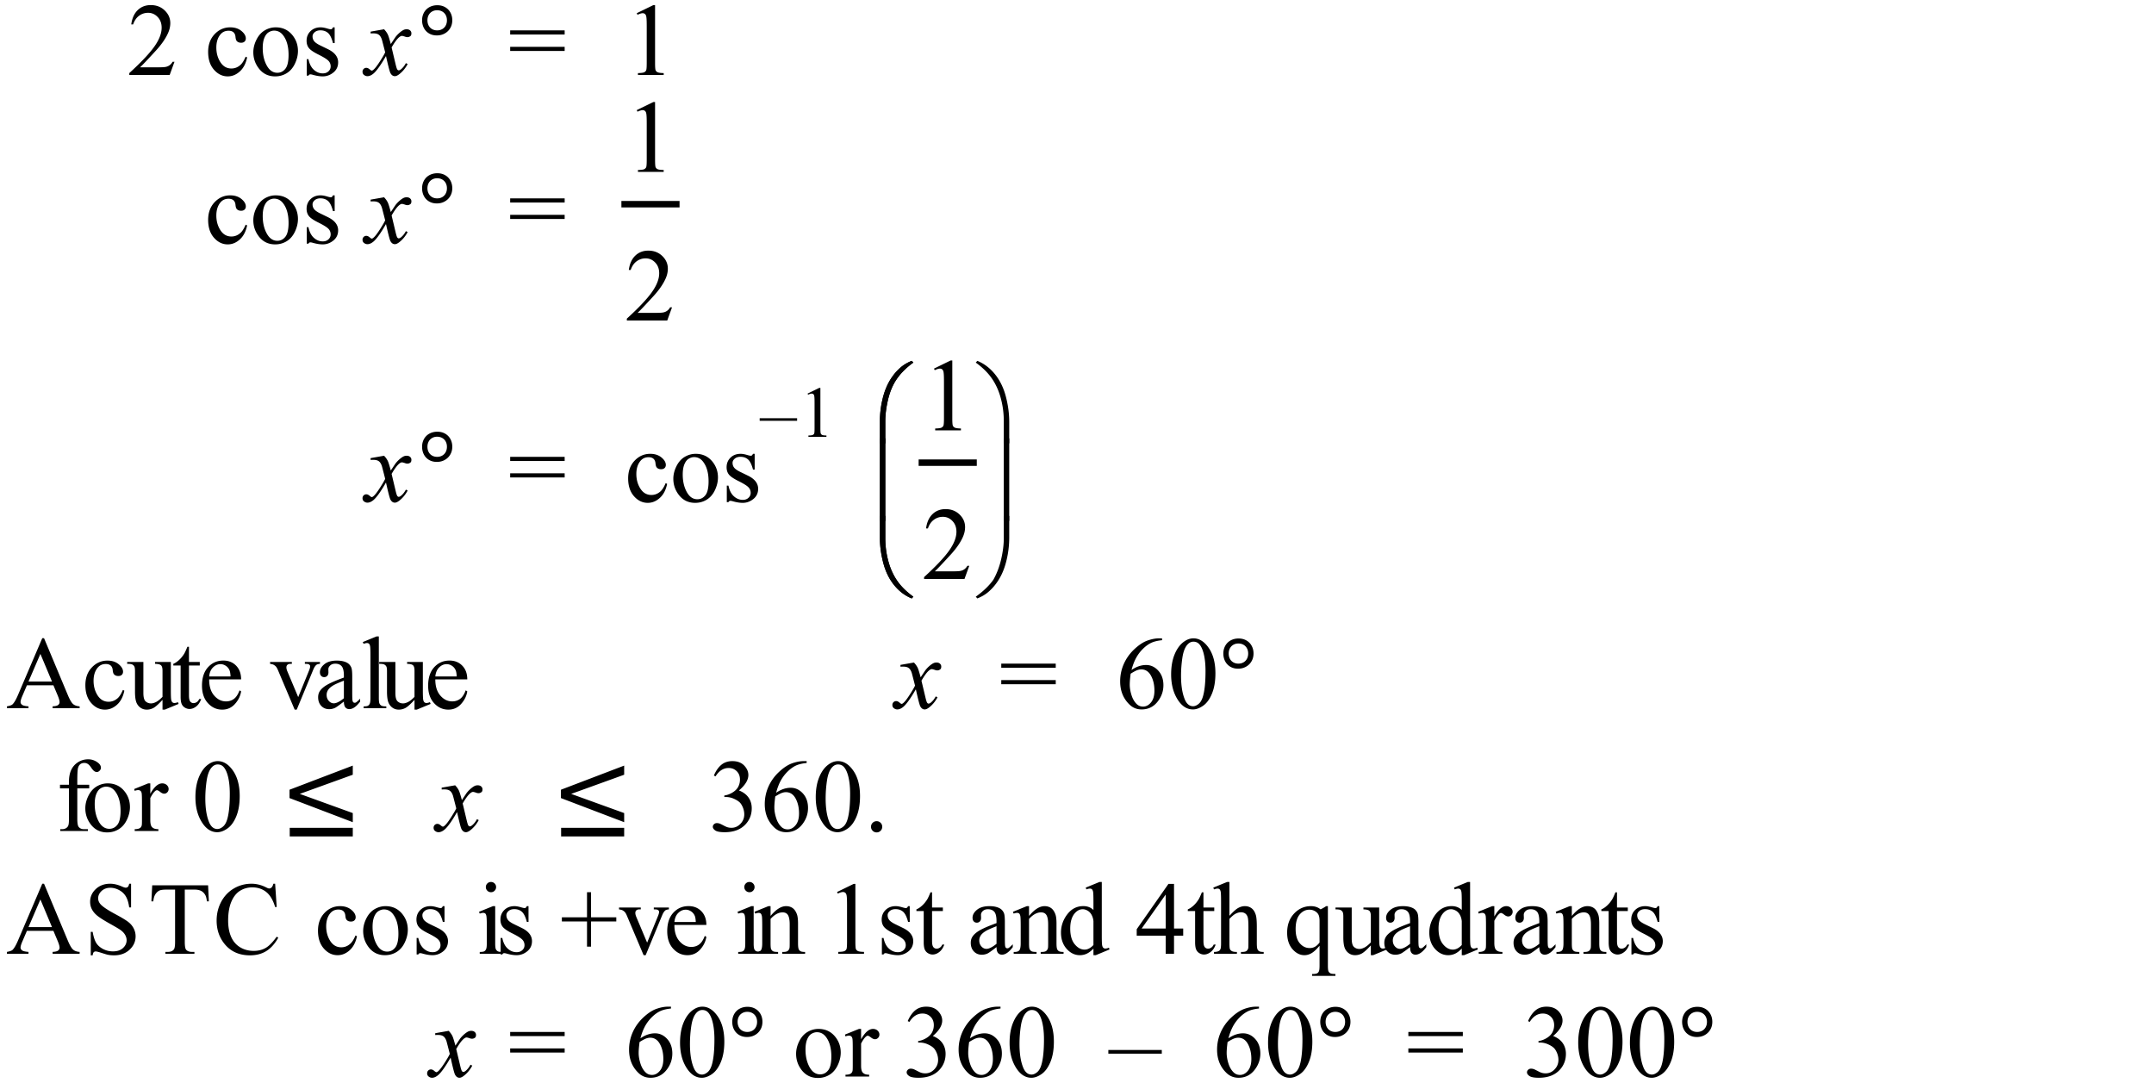 |  |  | B
 | 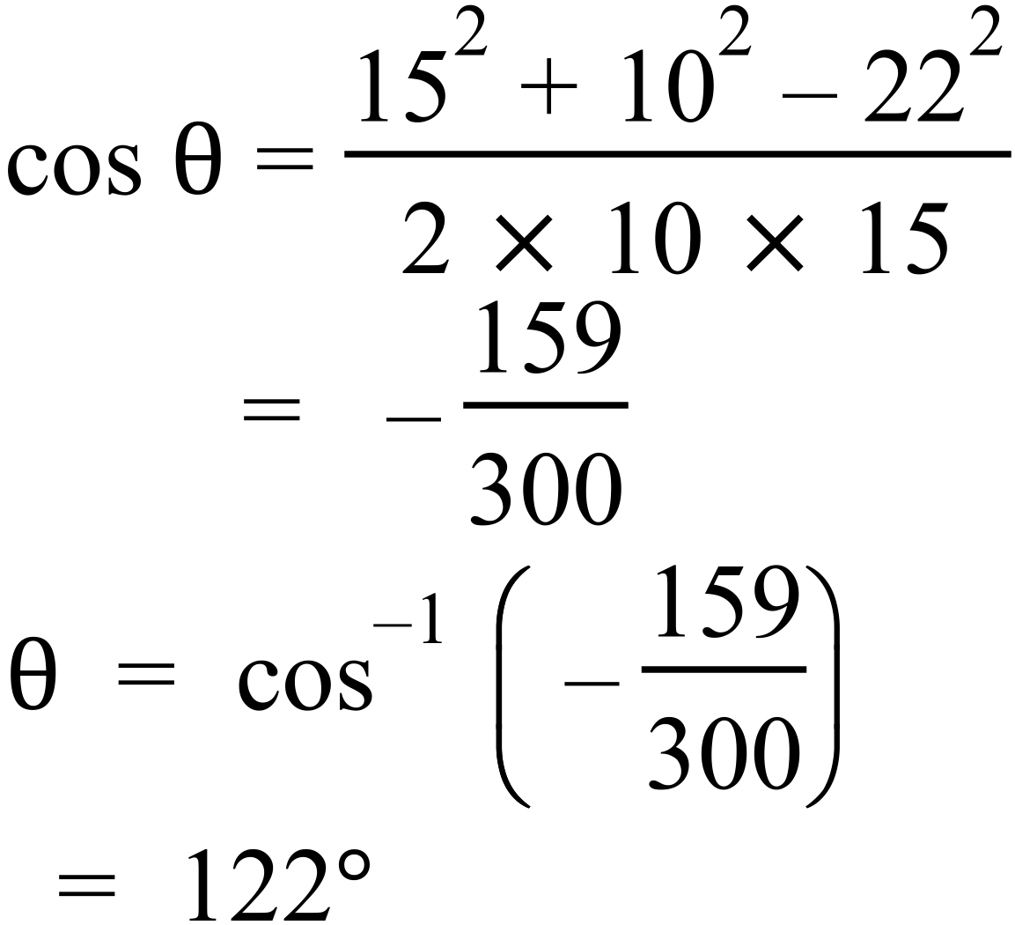 |  |  | C
 | 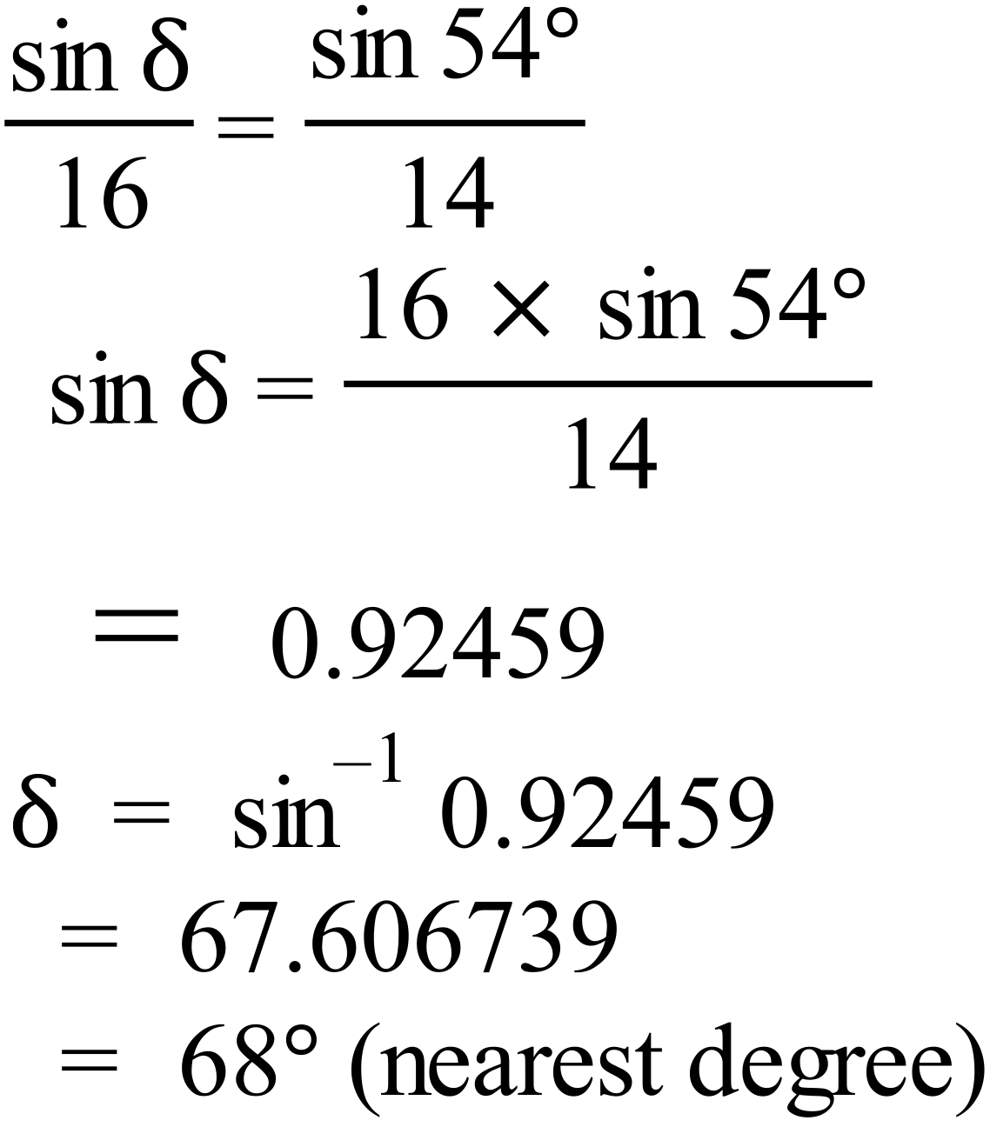 |  |  | D
 | 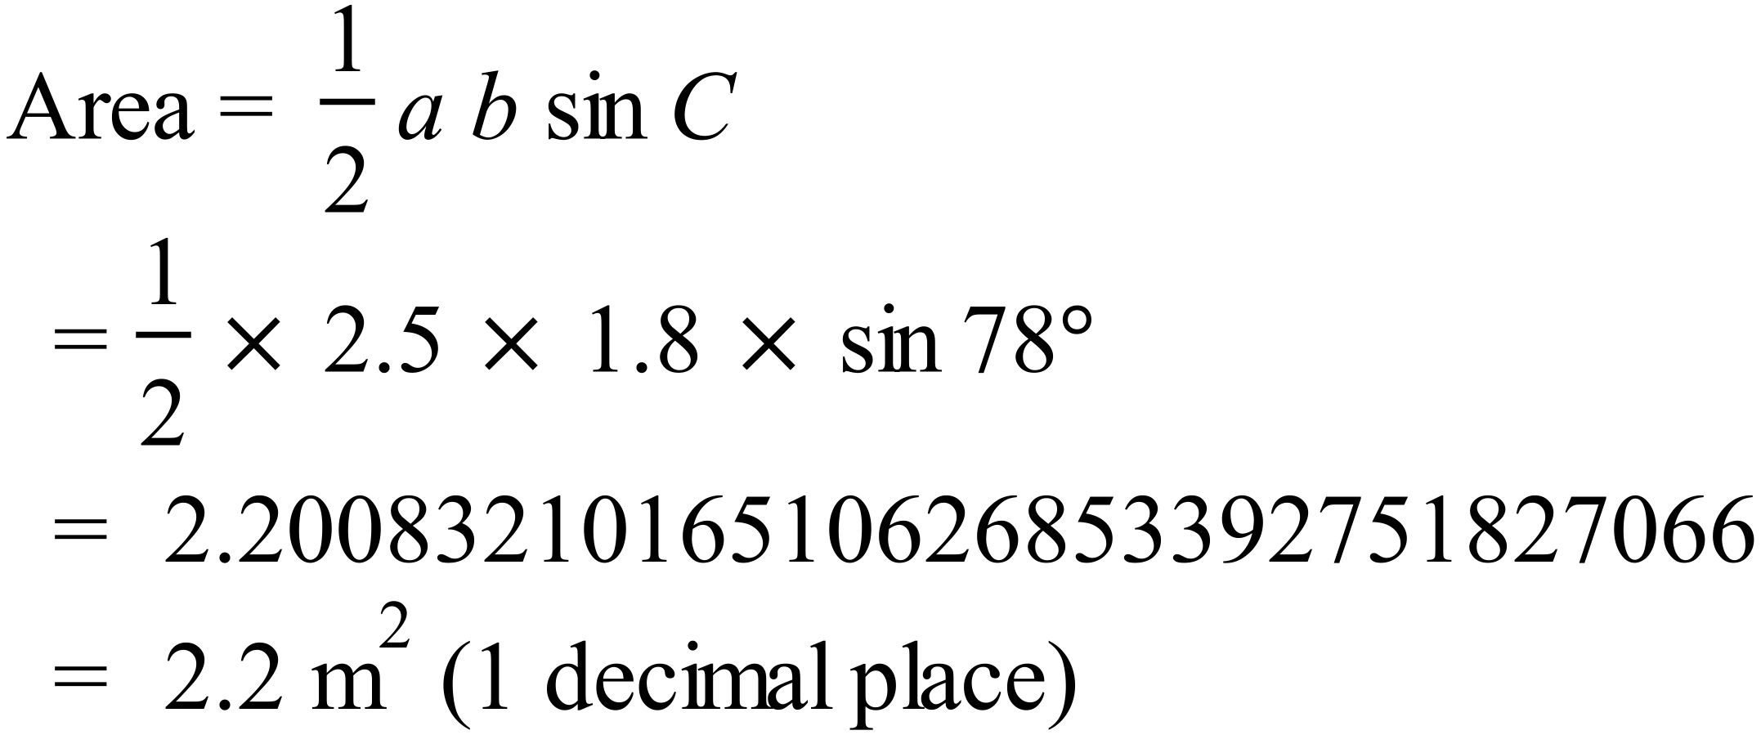 |  |  | A
 | 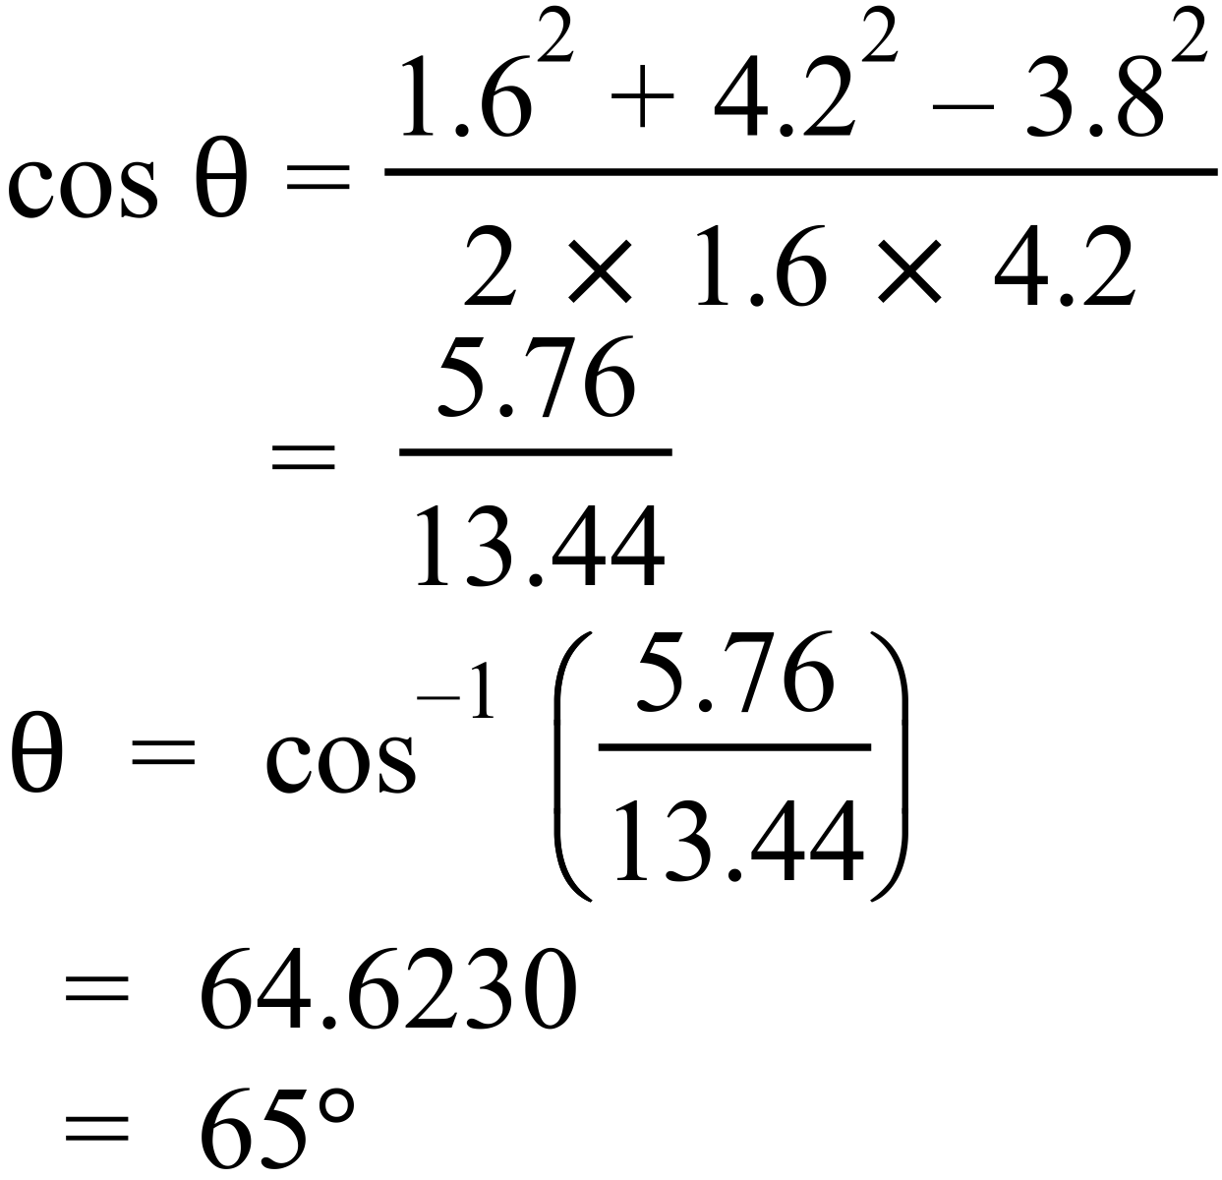 |  |  | C
 | 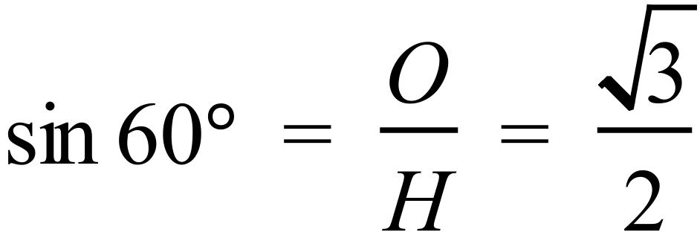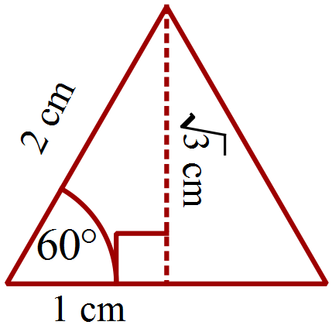 |  |  | C
 | 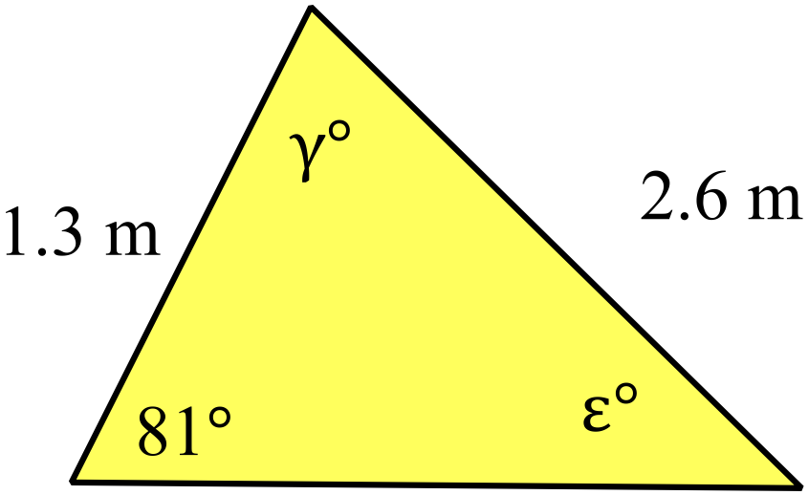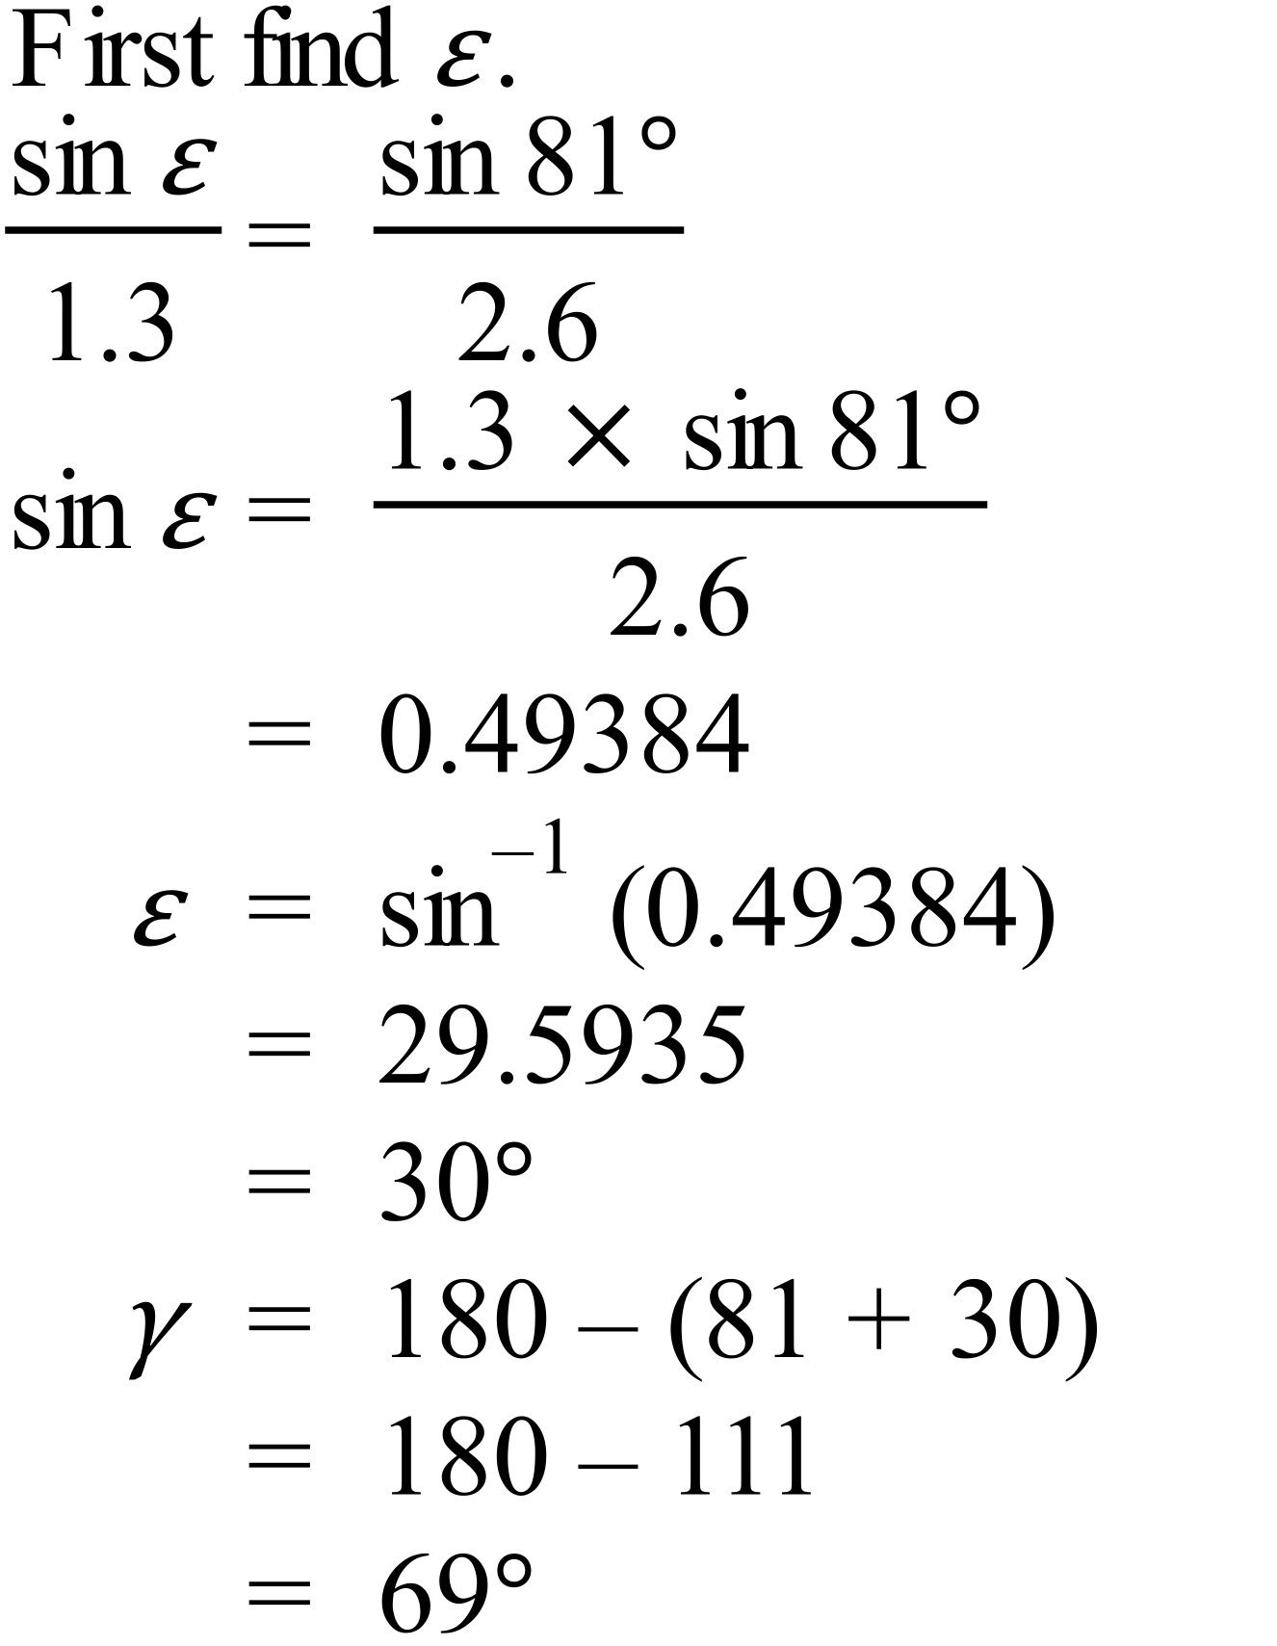 |  |  | B
 | 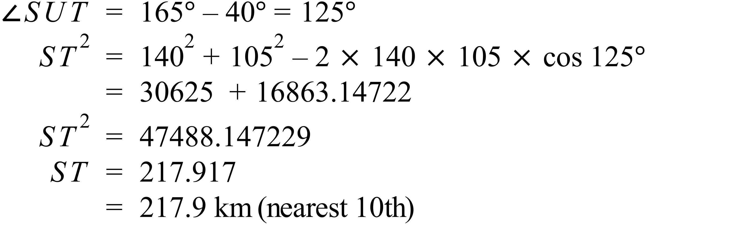 |  |  | C
 |  |  |  | A
 | 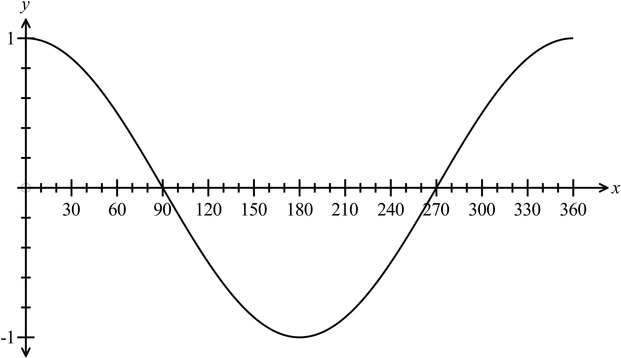Using a graph x = 90 and x = 270. |  |  | D
 | Using Pythagoras Theorem  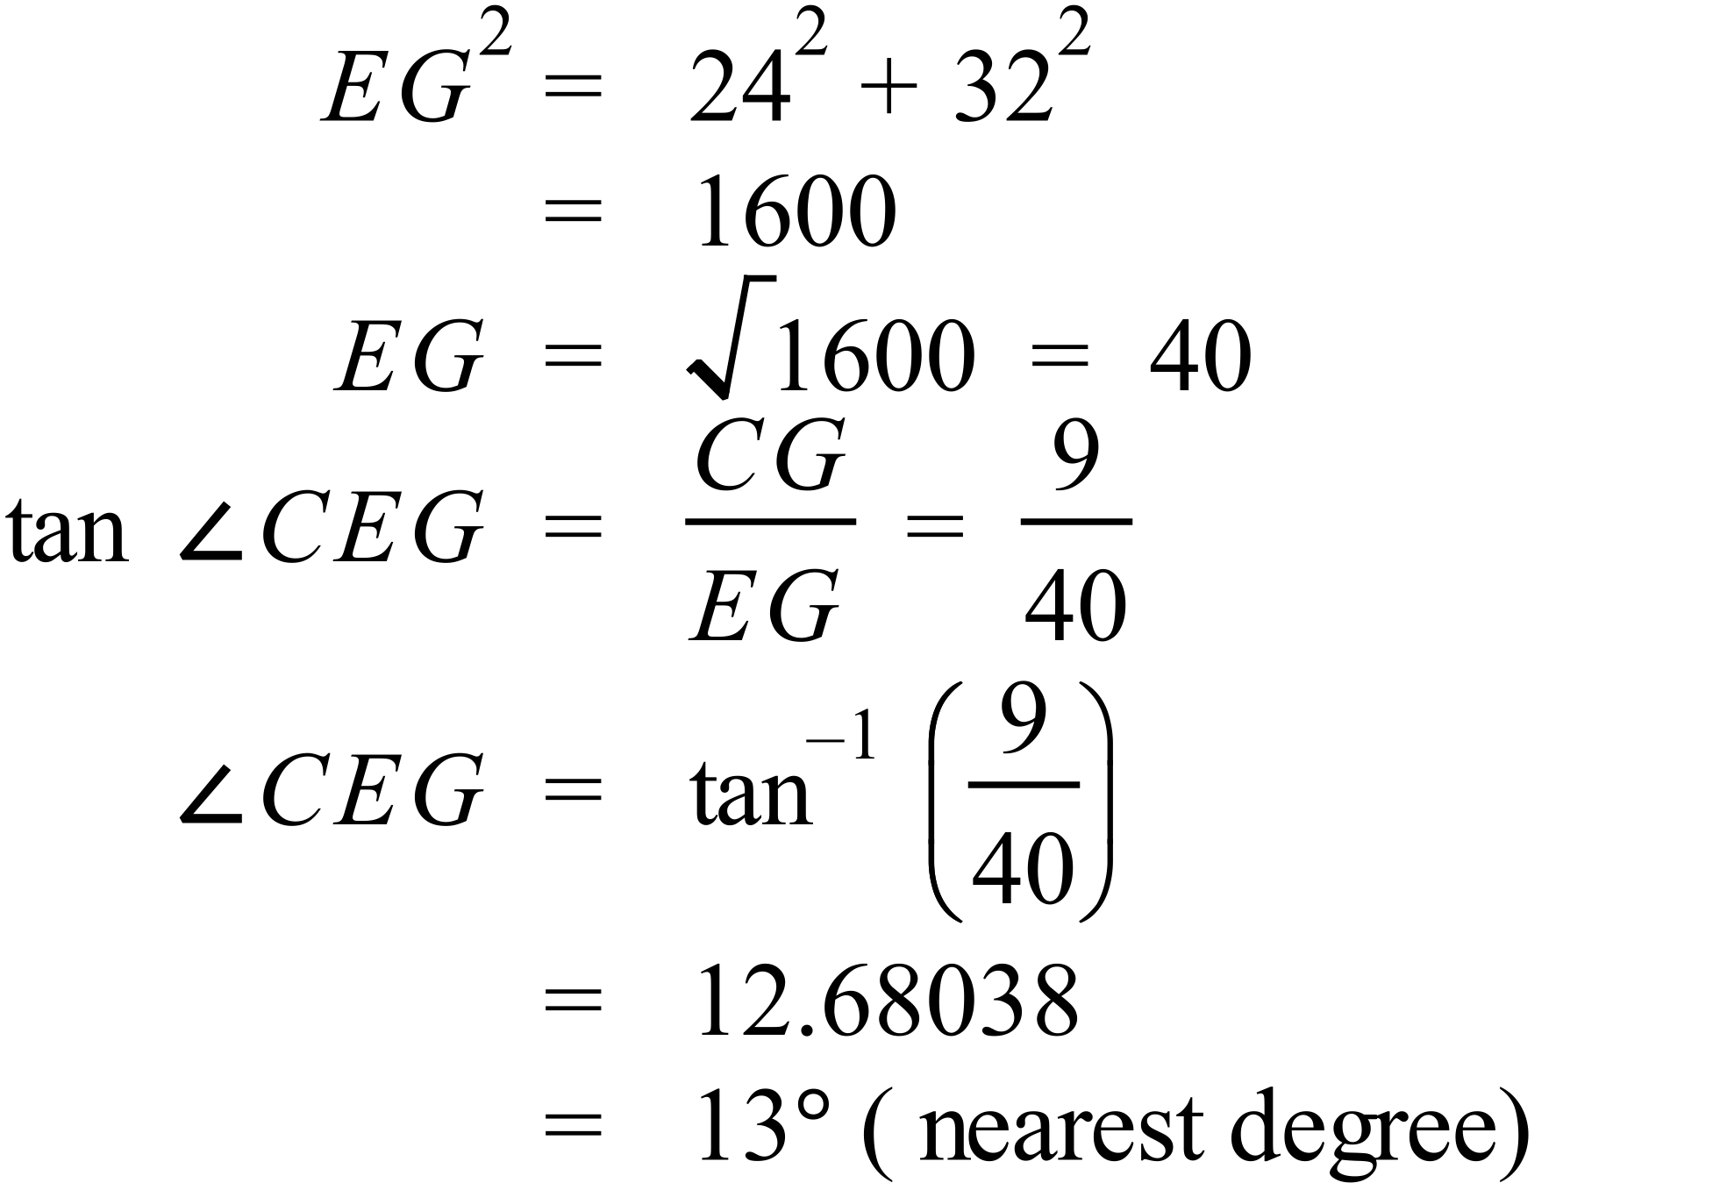 |  |  | A

Multiple Choice Answer Sheet
Non Right Triangle Trigonometry
Name _______ANSWERS_______________________________
Completely fill the response oval representing the most correct answer.

1. A B C D
2. A B C D
3. A B C D
4. A B C D
5. A B C D
6. A B C D
7. A B C D
8. A B C D
9. A B C D
10. A B C D
11. A B C D
12. A B C D
13. A B C D
14. A B C D
15. A B C D

